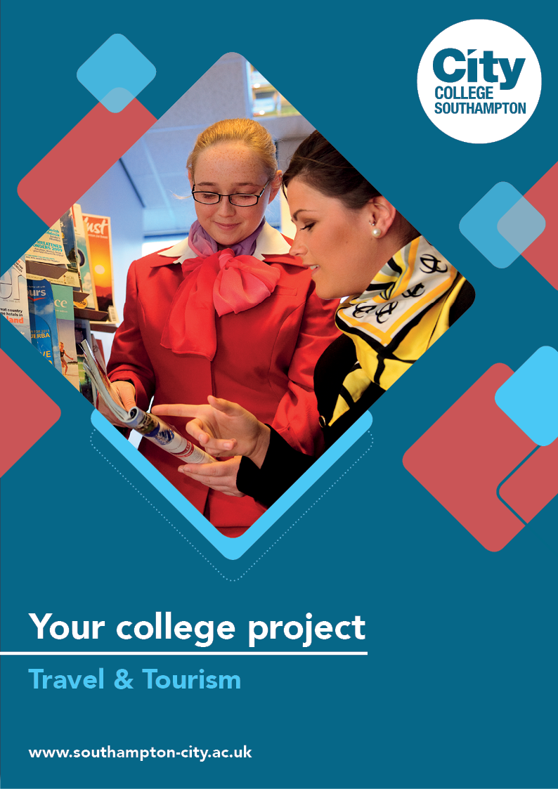
Travel & Tourism Summer Project

Name: ______________________________________
Welcome to Travel & Tourism at City College Southampton.
This is a series of short tasks to help you gain a little knowledge about Travel and Tourism and its industry before you start with us. Please bring this with you on your first day.

The pictures below are of holiday destinations, all of which are popular for different reasons and to different people and with differing budgets. There are links to videos which explain a little about them which will be useful to complete the project.
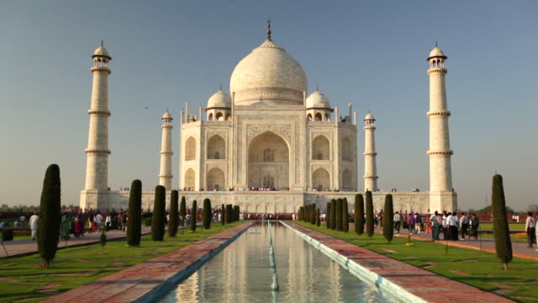
https://www.youtube.com/watch?v=49HTIoCccDY
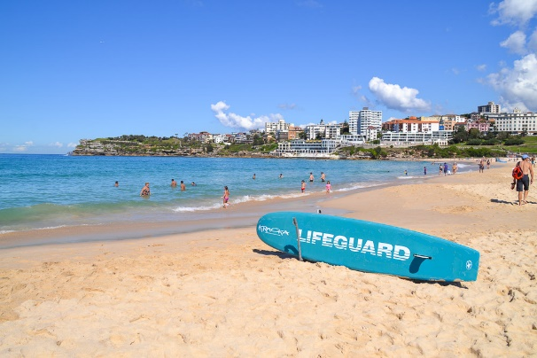
https://www.youtube.com/watch?v=uIFtlKCZ-dk
https://www.youtube.com/watch?v=prNQF0s9hu0
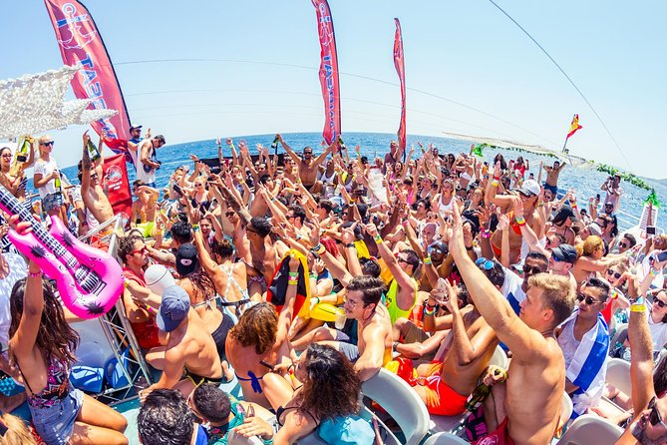
https://www.youtube.com/watch?v=yWlRaJNS4dc

Task 1
For each destination identify some key information;
- The destination
- Which country and continent is it located in and where is it located geographically? Find where on a map
- What is the climate like? When is best to visit?
- What is the population of the country?
- What language or languages are spoken? Do you require another language?
- What currency is used and what is the exchange rate with the UK Pound?
- What is the cost of living compared to that of the UK? How much money might you need – for example how much does a meal cost in a restaurant?
- How far is the destination from the UK and how long does it take to travel there? Can you arrive directly at the destination or are further forms of transport required to get there?
You could use a website such as https://www.rome2rio.com/
- Is it safe to travel there? Are there any health concerns and do you require vaccination? The following link can help with this information https://www.gov.uk/foreign-travel-advice
- Is the destination accessible to disabled people? Is it suitable for LBGT travellers? www.gaytimes.co.uk has lots of information to help with this
Task 2
Choose one destination and create a short itinerary for a visit – perhaps 3 days to a week. Think which destinations are more suited to this. Also consider what budget you have: Are you visiting luxury hotels or on a tight budget?
- What places are there that are of interest? This app is a useful tool https://www.getyourguide.com/

The following links will give you an idea of the kind of information you might give to a traveller:
https://www.jotform.com/pdf-templates/travel-itinerary-template
https://blog.headout.com/3-day-rome-itinerary/
https://www.eurostar.com/uk-en/city-breaks/paris/3-days-in-paris-itinerary
https://www.expedia.co.uk/ - this link may be useful to you to include flights and hotels and also costs.
Task 3
Choose a different destination and produce a brochure that would attract visitors to the destination.
This could be for a place, particular attraction or for a specific theme. For example you might concentrate on food or historical and cultural aspects. You may be interested in beach life or nightlife or those travellers who like to shop.
Use some of the information from task 2 to help with this. Think about what travellers arriving at a destination might be interested in, for example;
- Cost of hotels and facilities
- Eating out/bars
- Other attractions nearby
- Proximity to other places
- Accessibility and getting around
- Travelling with children
- Festivals and events
- Sports
If you have any travel guides, take a look at the information they provide. There are plenty online as well such as Lonely Planet, Footprint, and the Rough Guide. Travel Companies also supply much of this information about their destinations.
Get Creative! Make your brochure as visual as possible – use pictures as well as text. You can make it as a poster format or using Word or PowerPoint. Use A3 or A4 format and it should be a maximum of two sides.
List the sources that you have used to make your brochure - tell us where you found the information and what did you consider to be most useful in supplying information.

We look forward to welcoming you to City College in September and exploring what you have found out through this project - which you should complete and bring with you to your first lesson.

