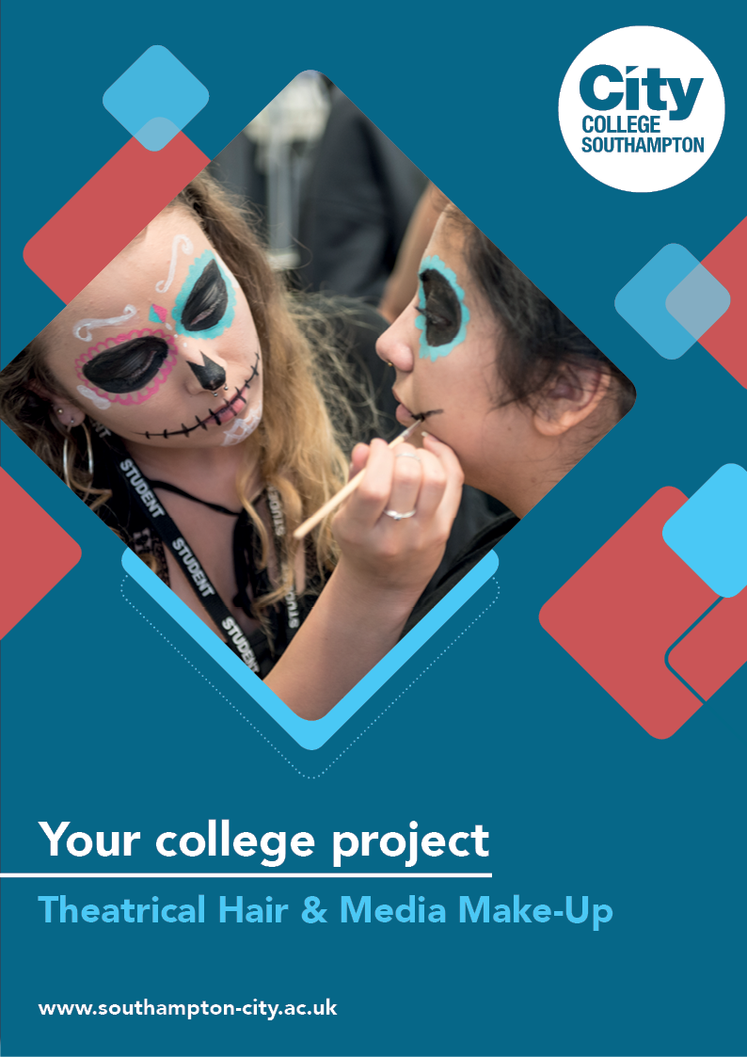
Theatrical Hair & Media Make-Up Summer Project

Name: ______________________________________
Welcome to Theatrical Hair & Media Make-Up at City College Southampton.
This is a series of short tasks to help you gain a little knowledge about hair and media make-up before you start with us. Please complete and bring this with you on your first day.

ICONIC​
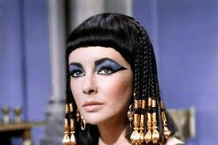
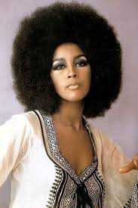
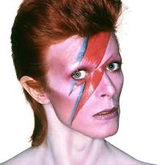
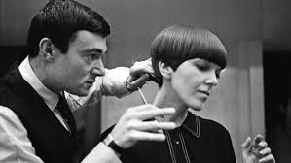
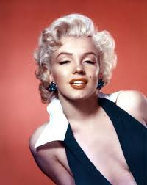
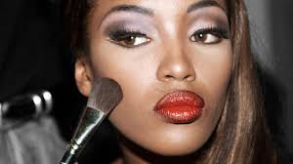
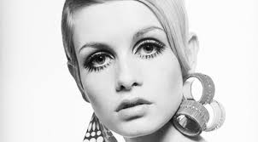
Make-up & Hair

Just like fashion and hair, make-up has changed drastically over the last century. From the early 20th century to present day, trends have varied from dramatic and bold to colourful and understated. What's amazing is that, although all the changes have happened, you can see certain trends being borrowed from past eras today.

Some make-up and hair styles can be considered as iconic. A style icon is a famous person, who has a certain style that is symbolic to them. Examples of style icons are Audrey Hepburn, David Bowie, Madonna, Marilyn Monroe, Bette Davis, Jean Harlow and Cleopatra.

Task 1: A Review of Iconic Make-up and Hair
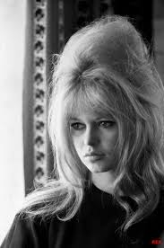
We would like you to research iconic makeup and hair from the eras 1900s to 2000, exploring the most famous trends, styles and icons at the time. For example, one of the most iconic models of the 60s was Brigitte Bardot, who was famous for her feline flick eyeliner, bouffant blonde hair and nude lipstick.

Identify your top ten style icons from the 1960s to the 2000, giving your reasons why each of them feature in your top ten.

Choose the hair and make-up styles you would most like to revive, explaining what it is you most like about each style.

Task 2: Creating a Mood Board

Choose 3 styles from the following list: 1920s flapper, 1940s Hollywood glamour, 1950s rock and roll, 1970s disco, 1980s pop culture, 1990s grunge. You can choose your own if you prefer.

Create a mood board or mind map to illustrate the most iconic make-up and hair from each era. Your work can be as colourful and creative as you like; you can include pictures, photographs and sketches to show us your ideas.

Task 3: Create a design

Create a design showing an iconic make-up look of your choice. You can use the face chart below or you can draw the design yourself.

Write an explanation of how you have created your design.
You could include:
- The products you would use​
- The era the design belongs to ​
- The trend you have based the look on e.g. punk, disco, glamorous etc.
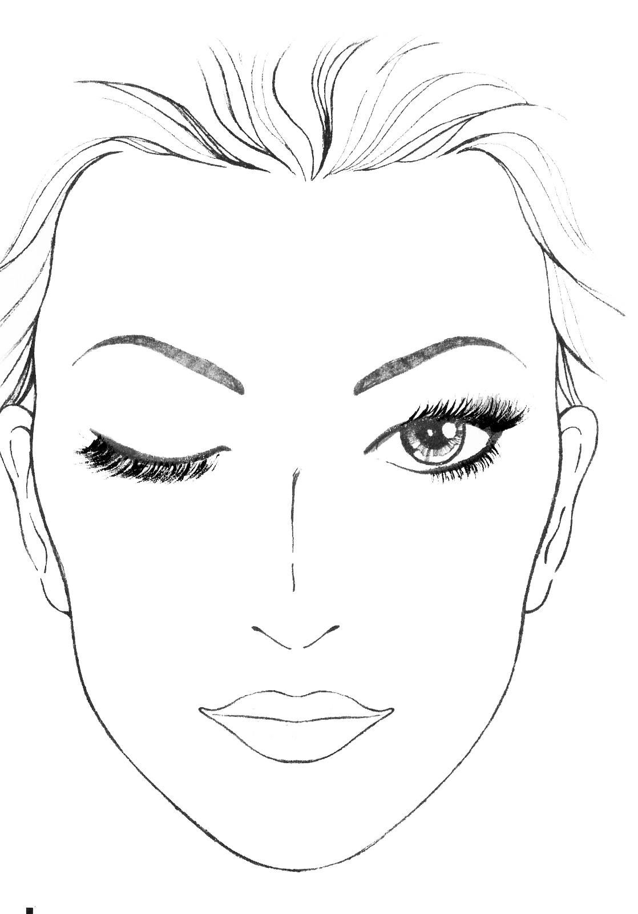
- Your own opinions of your design outcome

Task 4

Watch the Bardot Make-up Tutorial and answer the questions below.

https://www.youtube.com/watch?reload=9&v=O4P5VkpdtEY&list=RDQMoQEM3EiCIx4&index=18

1. List the products used in the tutorial and describe their purpose in creating the Bardot look.

2. How did Charlotte achieve the ‘smoky feline eyes’ and the ‘sun-kissed’ look?

3. Grade the tutorial out of 10, giving reason for your grade.

Useful links to help you with this summer project:

100 years of beauty icons:
https://www.youtube.com/watch?v=maEb5L1vjSc&t=3s

100 years of iconic hairstyles:
https://www.youtube.com/watch?v=PMrSzK2qvuY

Beauty through the years 1900-2000:
https://www.youtube.com/watch?v=R61ET3hdY0I&t=46s

Lisa Eldridge Marilyn Monroe Make-up Tutorial:
https://www.youtube.com/watch?v=RAneUTr8mog

How to create a mood board:
https://www.youtube.com/watch?v=m3Ln4BJ91CY

We look forward to welcoming you to City College in September and exploring what you have found out through this project - which you should complete and bring with you to your first lesson.

