Production Arts Summer Project

Name: ______________________________________
Welcome to Production Arts at City College Southampton.
At City College you will design, create and organise our live productions giving you real hands-on skills and building your portfolio for the next stage of your professional career. You will also review your own work and that of others to help you to keep improving.
This is a short activity to help you gain a little knowledge about the production arts industry and to give you some experience of reviewing a production before you start with us.
Please bring this with you on your first day of college so that we can discuss your ideas as a class.

Your Task
Watch a play online and review it.
You can watch the play that we have selected for you or you can visit the National Theatre at Home using the link below:

All My Sons - https://www.youtube.com/watch?v=IWYtHYe36L8 ‘All my sons’

National Theatre at Home: https://www.nationaltheatre.org.uk/nt-at-home
You will all have different skills sets so please review the play for the area you would most like to work in (i.e. lighting, sound, set design, stage management etc.). You need to recognise what was and wasn’t successful onstage.
- Provide brief details of the play you are reviewing, including its genre, its main actors and any interesting background information.
- Describe the plot of the play (for example, characters, scenes etc.)

- Thinking about your particular skills set, review at least one aspect of the production. This could be the lighting, sound, set design and/or stage management

- Identify your favourite part of the play and explain why you liked it the most.

- Describe what you would have done differently If you were a member of the production team.

Follow this link to the BBC Bitesize guide to writing about and evaluating the theatre. https://www.bbc.co.uk/bitesize/guides/zxs9xnb/revision/5

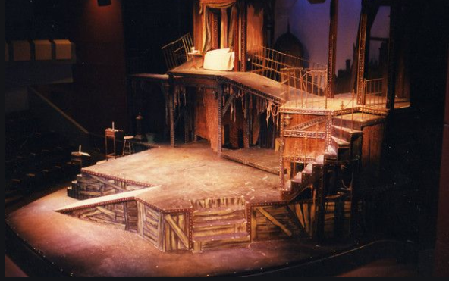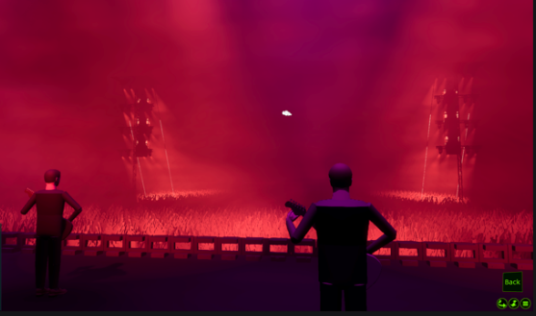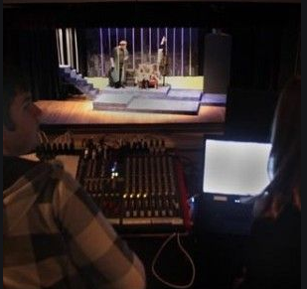

We look forward to welcoming you to City College in September and exploring what you have found out through this project - which you should complete and bring with you to your first lesson.

