Painting & Decorating Summer Project

Name: ______________________________________
Welcome to Painting & Decorating at City College Southampton.
This is a series of short tasks to help you gain a little knowledge about Painting & Decorating and the construction industry before you start with us. Please bring this with you on your first day.
Task 1
The video shows you what to expect when you visit a large site for the first time. It is called an induction and is designed to keep everyone on the site safe. Even very experienced workers have to complete the induction before they start work, as every site has different risks and hazards
Watch the video and answer the questions. Approximate times are given as a guide.
Site Safety Induction - https://www.youtube.com/watch?v=eW7GBuaBuek
- Why does a building site need to be secure? (1:50)

- Can you identify four of the blue and white safety signs? What type of signs are blue and white and circular? (3:00)

- Give three examples of PPE (Personal Protective Equipment) used in construction and state what each is designed to protect you from. (3:45)

- Why do health and safety signs differ in colour? (6:20)

- Fire extinguishers are colour coded. Choose three extinguishers, name them, identify the colour coding and explain which types of fire each is used on. (6:40)

- Who are the HSE and what is their role in construction? (10:00)

- Who are the Health and Safety laws protecting in the Construction Industry? (11:20)

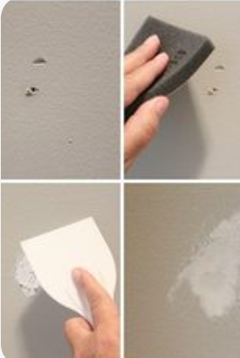
Task 2
Within your first few weeks at College you will start to develop your painting and decorating skills. You will quickly learn how important it is to prepare walls and ceilings for painting.
Watch this video which shows you how to prepare walls and ceilings and answer the questions below.
https://www.youtube.com/watch?v=_S7x6JVTffw

- What did the presenter identify as the three principals of preparing a wall?

- Why did the newly plastered wall need to be primed? What is the alternative to priming?

- Why is it necessary to remove dust and grease from a previously plastered wall?

- Why did the presenter fold the sandpaper when sanding the previously painted wall?

- How does a steam stripper work?
Task 3
An important aspect of your job as a painter and decorator will be calculating how much paint you will need to do a job.
Watch this video and answer the question below. https://www.youtube.com/watch?v=bCDdQC-zrPs
Look at this plan for a flat (not to scale)
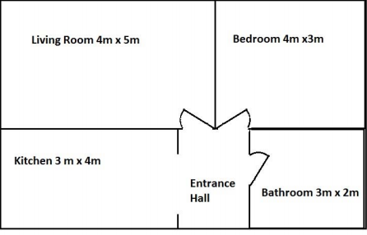
The ceiling height is 3m throughout the flat and each room requires two coats
of paint.
How many 10 litre tins of paint will you need to paint the flat?
Task 4
As a painter and decorator you will need a set of tools. Every painter and decorator is different and the tools they swear by are as much about personal preference as they are about experience. From the brands of brushes they use to the type of paint they buy, every trade professional will have their own thoughts on what works best.
Make a list of the tools that you feel would make a good toolkit for you as a trainee painter & decorator.
Now that you have a list of tools ready, use the internet to research the price of each tool.
Here are a couple of websites that we recommend:
Decorating Warehouse - https://www.decoratingwarehouse.co.uk/
Toolstation - https://www.toolstation.com/

It is a good idea to compare prices from a number of suppliers as costs can vary.
Put the individual price per tool and the total cost into the table below. We will see who gets the best deal for their tools in induction.
Tool Name | Website address | Cost
Total for all tools

Check out these links to learn more about the type of practical activities you will be doing on your course.
Painting & decorating techniques
Marbling technique - https://youtu.be/aFsTGjGVzcE
How to apply French Wash - https://youtu.be/DxMBvv1ITg8
Faux Oak Wood Grain Creative Painting Techniques - https://youtu.be/u_fRpJUyBDg
Practical decorating techniques - https://www.youtube.com/watch?v=bGsdzJmJHrg
These links will show you how colour can be used to give a sense of colour and mood.
https://www.duluxtradepaintexpert.co.uk/en/editorial/5-essential-decorating-schemes-every-decorator-should-know
https://www.idealhome.co.uk/living-room/living-room-ideas/living-room-paint-ideas-184517

We look forward to welcoming you to City College in September and exploring what you have found out through this project - which you should complete and bring with you to your first lesson.

