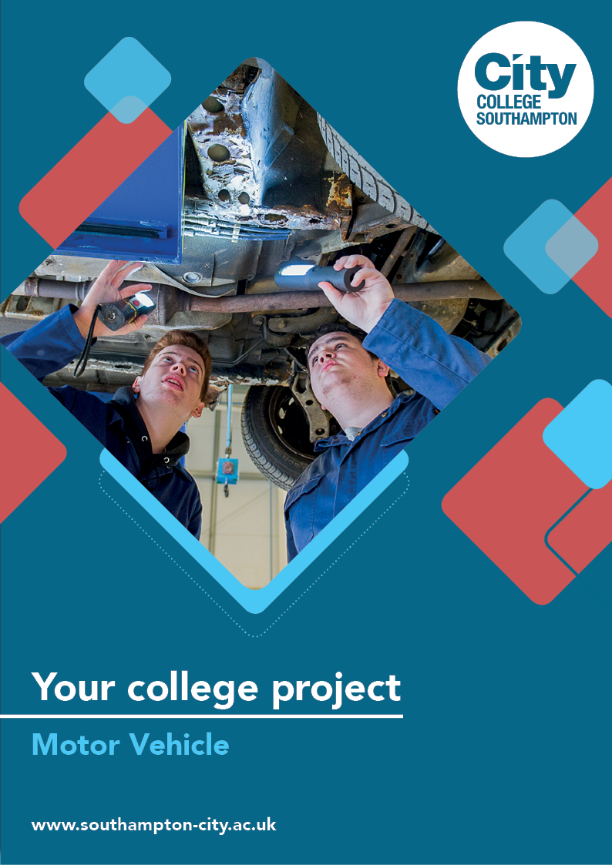
Motor Vehicle Summer Project

Name: ______________________________________
Welcome to Motor Vehicle at City College Southampton.
This is a series of short tasks to help you gain a little knowledge about motor vehicle and its industry before you start with us. Please complete these tasks and bring this with you on your first day.

Task 1: Health and safety
Please carry out the quiz below. This will give us an indication of what you already know with regards to health and safety.
Task 2: Tools and Equipment
Please follow the 2 links to CityTube and carry out the Garage game show. This will give us an indication of what you already know with regards to tools and equipment. The answer sheets to complete are included below each link.
https://citytube.southampton-city.ac.uk/View.aspx?id=5516~4r~SDdBPyeZ&code=WU~U3fUCDuqQkfOttrcV3ImtnVqHZ79m3PGBrPcmcU2dbraTOU3PtjvE6eGe9CsdjNHBNzIV2QjKrt7gSth6oWGU2VDbFhwX8LY&ax=6U~MztVrxrgJlfo
https://citytube.southampton-city.ac.uk/View.aspx?id=5518~4t~V0IOjwBJ&code=WU~U3fUCDuqQkfOttrcV3ImtnVqHZ79m3PGBrPcmcU2dbraTOU3PtjvE6eGe9CsdjNHBNzIV2QjKrt7gStj6pWCU2VAbDhpX7LW&ax=6N~dDr4xfS2AN9a
Task 3: Under the bonnet quiz
Please follow the link to CityTube and carry out the Under the Bonnet quiz. This will give us an indication of what you already know with regards to basic engine operation.
https://citytube.southampton-city.ac.uk/View.aspx?id=5545~4t~V0IOjzBG&tlid=11&code=Ve~cXViCSvfpxf4mGI8h0JqzyzpSXtrh3xvl6WLxM9etLcvy7V0LB73aBn8GwFXchH6fwVCWJpzuwjJC7ULTGpV6vmEMyx7UYfsdmsQLZ&ax=6W~OX7XMKNWEbTb
Task 4: The Internal Combustion Engine
Research and find out what the 4 strokes are called in the four-stroke cycle of an engine.
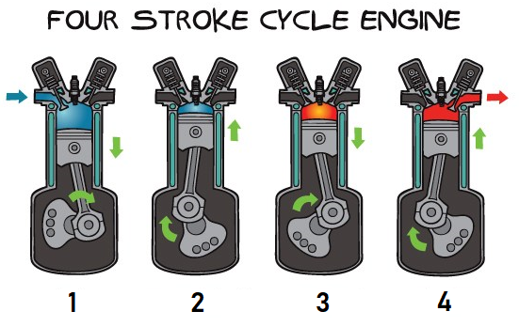

1.
2.
3.
4.
In your own words briefly describe what is happening in each of the four strokes of the four-stroke cycle.

Now, please follow the link below and carry out the online Engine Components quiz. This will give us an indication of what you already know with regards to engine components.
https://citytube.southampton-city.ac.uk/View.aspx?id=5548~4w~xZCroJiB&tlid=2&code=Ve~cXViCSvfpxf4mGI8h0JqzyzpSXtrh3xvl6WLxM9etLcvy7V0LB73aBn8GwFXchH6fwVCWJpzuwjJC7ULTGpV6ymFMAx8UVfsdlsQLW&ax=6Q~HNkHCsyTTEGe
Task 5: Electrics quiz
Please click the link to CityTube and carry out the online Alternator Testing quiz. This will give us an indication of what you already know with regards to electrical testing.
https://citytube.southampton-city.ac.uk/View.aspx?id=5549~4x~8AS48ItY&tlid=5&code=Ve~cXViCSvfpxf4mGI8h0JqzyzpSXtrh3xvl6WLxM9etLcvy7V0LB73aBn8GwFXchH6fwVCWJpzuwjJC7ULTGpV6zmGMux9UVfldusXLX&ax=6R~ipAjmrKhquzw

We look forward to welcoming you to City College in September and exploring what you have found out through this project - which you should complete and bring with you to your first lesson.

