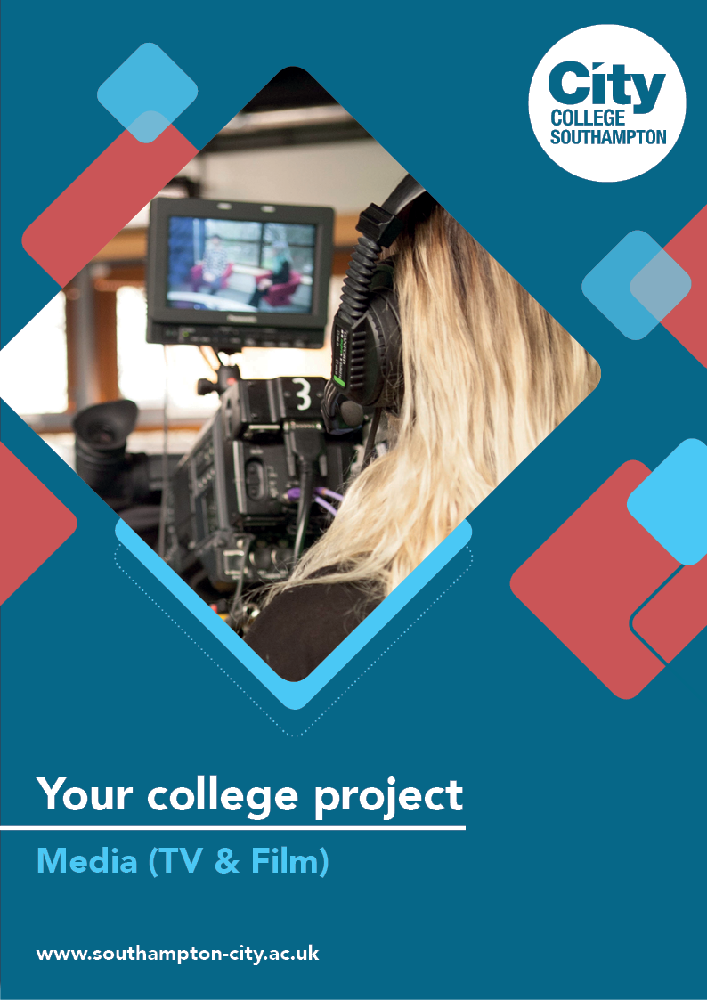
Media (TV & Film) Summer Project

Name: ______________________________________
Welcome to Media (TV & Film) at City College Southampton.
This is a short summer project to help you gain a little knowledge about media and the TV & film industry before you start with us. Please bring this with you on your first day.

Summer Task: Music Video
Making a TV show or film is a complex operation that has a lot of thought and planning put into it - it doesn’t just happen!
Watch this video to understand some of the ins and outs of making a music video.
https://www.youtube.com/watch?v=FovXH9oloH8&feature=youtu.be
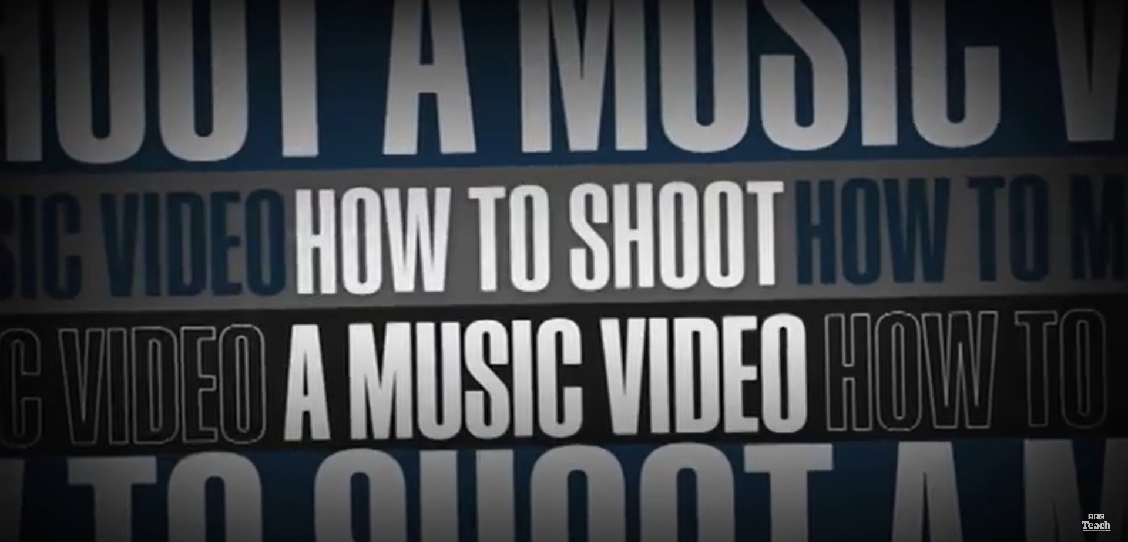
Select a music track that you like and think about what sort of music video you would create for it.
Will it be a narrative one that follows the lyrics of the song? Will you be putting across a message through the video? Will it show the musicians performing? Or will you be going all out to create something totally original?
Copy out the lyrics and think about what shots you would use. Using a storyboarding frame, draw out the shots that you would take - think about the pace of the song, the framing of the shots and how the camera might move. Don’t worry too much about your drawing skills - it’s more about your creative ideas.
Useful resources:
Three types of music video:
https://www.youtube.com/watch?v=9sDXwZ3JuNY
Camera Shots and Movements: https://www.empireonline.com/movies/features/film-studies-101-camera-shots-styles/
What is a storyboard?
https://www.youtube.com/watch?v=6aTnEanIXBk
Storyboard template:
https://downloads.boords.com/free/A4-landscape-6-storyboard-template.pdf
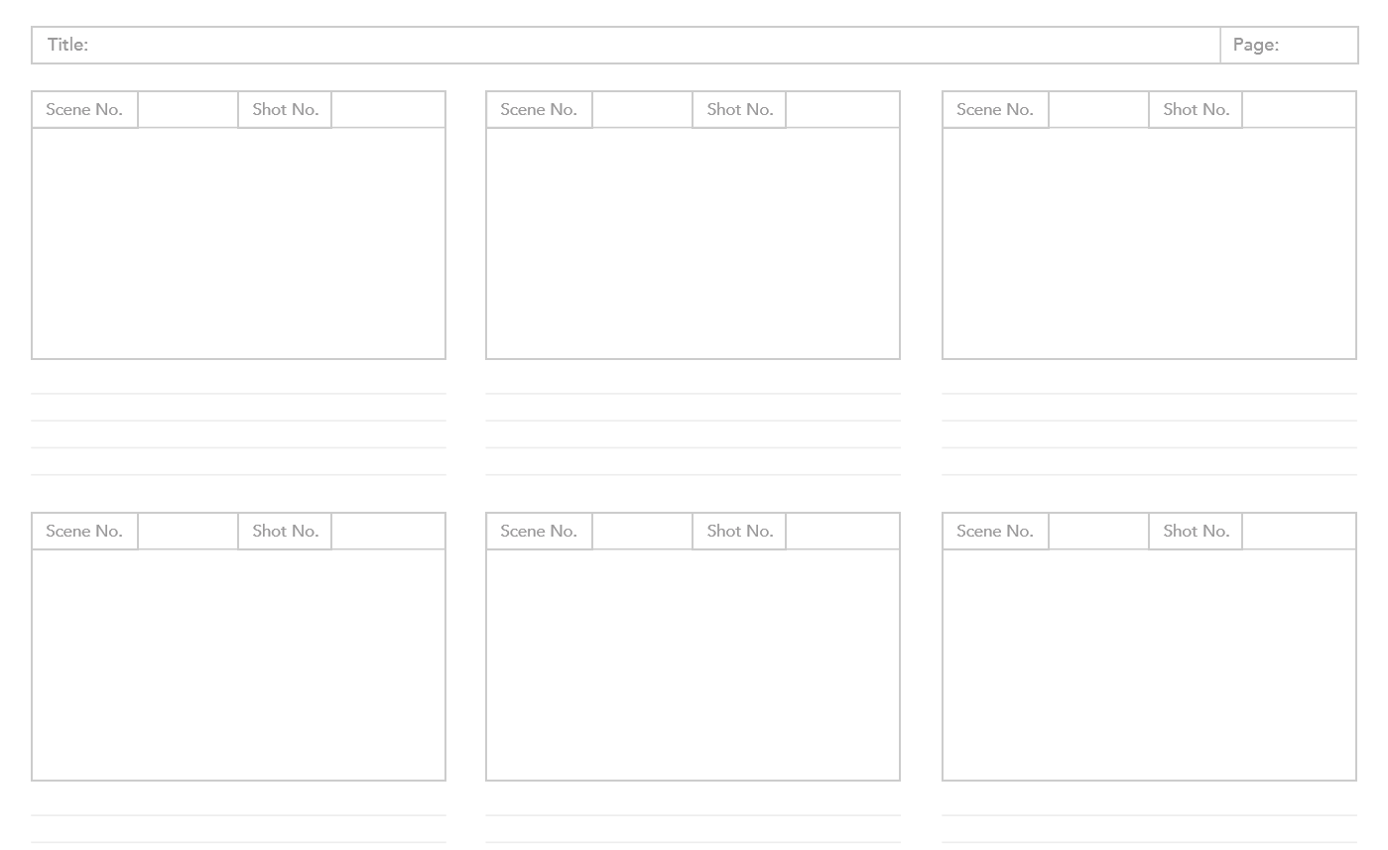

We look forward to welcoming you to City College in September and exploring what you have found out through this project - which you should complete and bring with you to your first lesson.

