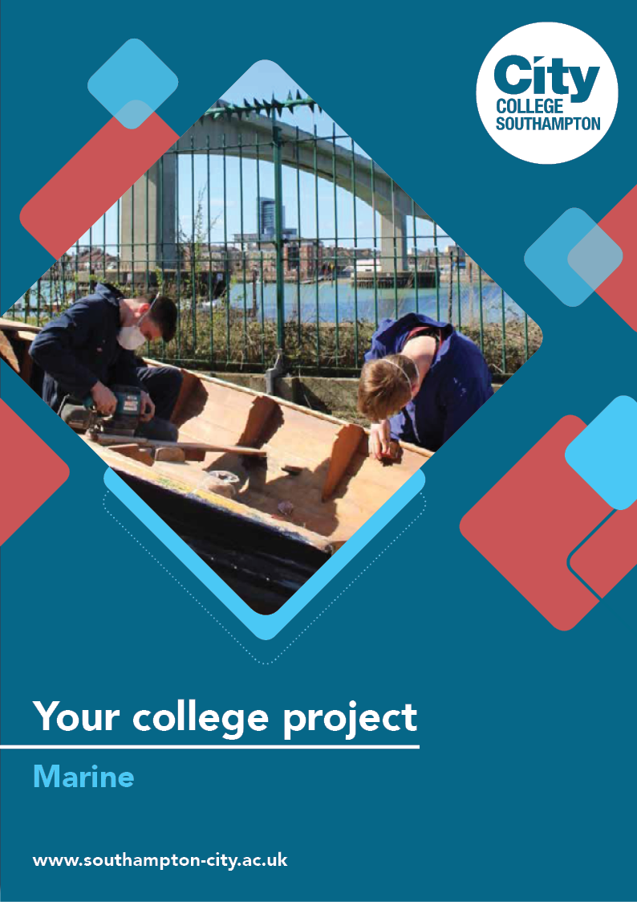
Marine Summer Project

Name: ______________________________________
Welcome to Marine at City College Southampton.
This is a series of short tasks to help you gain a little knowledge about the marine industry before you start with us. Please bring this with you on your first day.
The Marine industry encompasses a wide range of skills, from traditional boat building through to electrical fault finding with many others in between.
Completing these five tasks will help prepare you for your Level 2 Marine course, and give you an insight into a potential career in an exciting and innovating industry.
Task 1 – Health and safety – Every good job starts with it!
An essential part of any job in the Marine industry is protecting yourself and others. In the UK this is achieved through the correct implementation of existing Health and Safety laws and guidelines.
Answer the following five questions
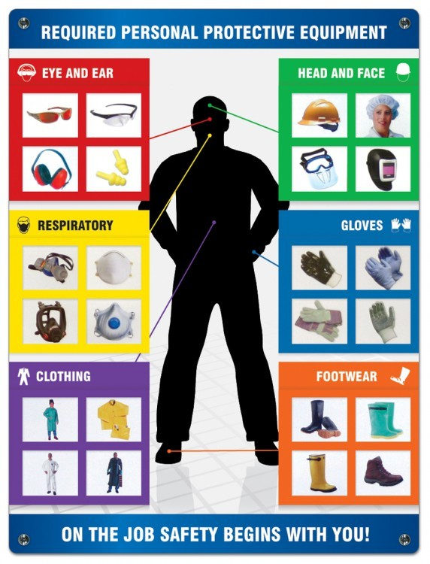
- Label the six examples of personal protective equipment (PPE) shown below

- Give one reason for using each of the 6 items of PPE shown in question 1.

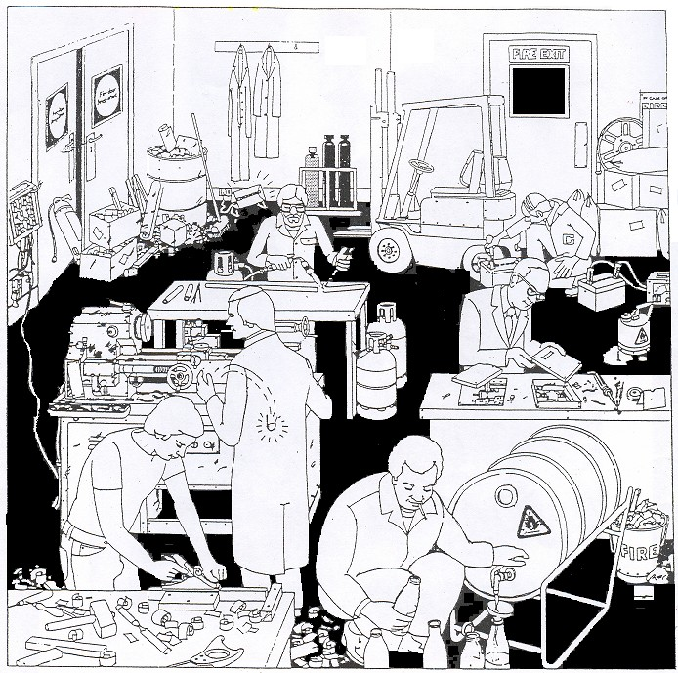
- Identify the Hazards in the picture below.
- What constitutes working at height?
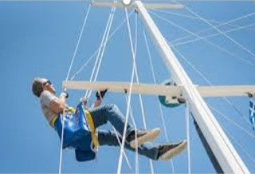
- What does the acronym COSHH stand for?
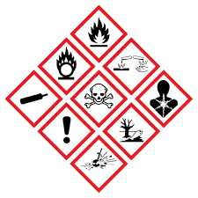

Task 2 – Boat Building
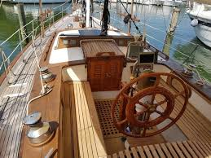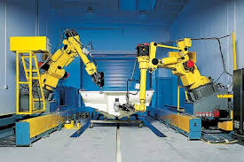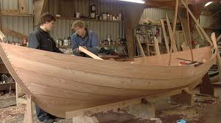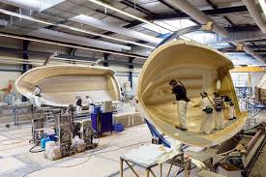
Boat Building can be split into two areas;
Traditional - using wood and wood joining techniques
Modern - using the latest carbon fibres, resins and glues
More commonly boats are made using a combination of both techniques.
https://www.youtube.com/watch?v=Wu7EYNm3l8Y
Watch this video about constructing a simple dinghy.
Make a note of the following (watch the video again if you need to):
- Different materials used to construct the simple vessel – why do think those materials were chosen?

- Different tools used

Can you suggest any different tools or materials which would be suitable to construct the same dinghy? Explain why you think they would be suitable. Use the following links to help you.
Boat Building Materials -
http://www.youboat.net/diy/boatmaterials.aspx
DIY Wood Boatbuilding Tools –
https://www.diy-wood-boat.com/boatbuilding_tools.html#Boatbuilding_tools

Task 3 - Marine Engineering
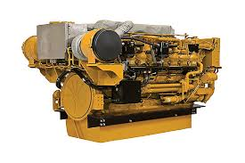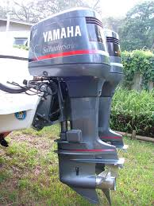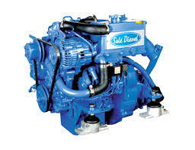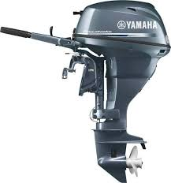
Marine engineering is a broad term and can include all sorts of different job roles from service engineers and surveyors to boat designers and structural engineers. Whilst studying at the Marine Skills Centre, your engineering training will be focused on how to service, maintain and diagnose faults in small to medium vessels - primarily in the leisure marine market.

The picture above shows a single cylinder from a Compression Ignition (CI) engine.
- Can you label the components shown in the picture with the correct terms listed below:
- Oil sump
- Crankshaft
- Air inlet
- Exhaust
- Engine block
- Piston assembly
- Rocker gear
- Inlet and exhaust valves

Use the following links to check your answers or to help you if you are unsure. These videos explain engine construction and much more.

Components of an IC Engine -
https://www.youtube.com/watch?v=W01aN-S8AXg

What is a Compression Ignition Engine? - https://www.mechanicalbooster.com/2017/10/compression-ignition-engine.html

- What does the term Compression Ignition (CI) engine mean?

Task 4 - Marine Electrical
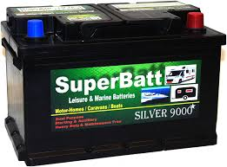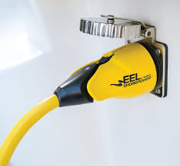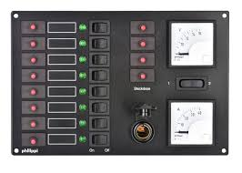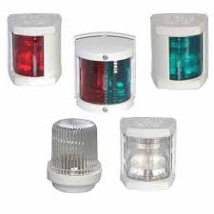
It is increasingly common in the marine industry for marine service/maintenance engineers to be asked to carry out electrical maintenance alongside their traditional roles. At the Marine Skills Centre you will be taught basic electrical wiring and conventions as well as circuit design and fault finding.

- Label the pictures with the correct names listed below
Battery, Fuse, Resistor, Relay
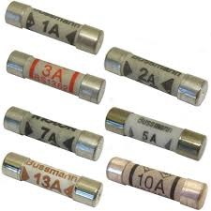 | 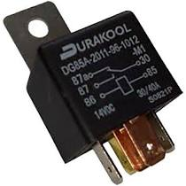 | 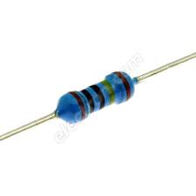

- For each of the electrical components above write a short description which explains their use within an electrical circuit. The following links will help you:

How Electronic Components Work -
https://blog.mide.com/how-electronic-components-work

Basic Electronic Components -
https://www.dummies.com/programming/electronics/basic-electronic-components-and-what-they-do/

A Complete Guide To Fuses -
https://www.swe-check.com.au/editorials/fuses.php

- Battery

- Fuse

- Resistor

- Relay

Task 5 - Work Experience
One of the requirements of completing your Level 2 course is to undertake a minimum of 37 hours of work experience, ideally within the Marine Industry or another related trade. It will be your responsibility to find and secure a suitable work placement.

Prior to starting college in September, we would like you to research the type of Marine career opportunities that are available and decide which ones interest you most.

Investigate Marine industry companies and organisations (large or small) that are within commuting distance of where you live with a view to approaching them to secure work experience.

You may want to use these links to help you understand the different opportunities available to you.

https://britishmarine.co.uk/Careers-and-Training
https://www.marineinsight.com/careers-2/50-marine-careers-essential-guide/

Complete the following form
Which career in the Marine industry interests me the most?
What skills will I need to work in my preferred role?
Company or organisation I would like to complete work experience with. List three.
Name
Address
Contact details
(Include website, email and phone numbers)
Name
Address
Contact details
(Include website, email and phone numbers)
Name
Address
Contact details
(Include website, email and phone numbers)

We look forward to welcoming you to City College in September and exploring what you have found out through this project. Please bring these completed tasks with you to your first lesson.

Kind regards
Team Marine

