IT & Digital Communications Summer Project

Name: ______________________________________
Welcome to Computing and IT at City College Southampton.
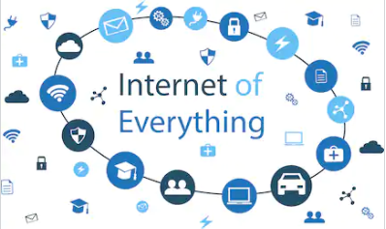
This is a series of short tasks to help you gain a little knowledge about IT & Digital Communications before you start with us. Please complete and bring this with you on your first day.
Task 1
Watch this video from IBM:
https://www.ibm.com/blogs/internet-of-things/what-is-the-iot/
The concept of “The Internet of Everything” is a rapidly growing area of technology.
- Do some research around the topic then write a description of the meaning of the internet of everything.
In particular, look for information about the use of “Internet of Everything” in the field of Medicine and how it is being used in homes.
This is a short video about use in homes, think about how the internet can enhance family life in terms of entertainment, education and communication. This is particularly relevant in terms of the 2020 lockdown
https://www.youtube.com/watch?v=h4M3yz5WllY
- Watch and read the article on medicine
https://igniteoutsourcing.com/healthcare/internet-of-medical-things-iomt-examples/
- Write a short report on your findings
- Make sure you describe any potential drawbacks as well as their uses and advantages they offer
- What are future trends? How will the technology develop and what areas of life will it affect? Remember, this may be both positive or negative
- List the sources you used to gain the information and describe what was most useful
Task 2
What is a programming language and why do we use them? Watch the following to answer the question
https://edu.gcfglobal.org/en/computer-science/programming-languages/1/
Use the following to help you compile a list of programming languages and provide a brief explanation of their use, advantages and disadvantages and any future developments
https://www.computerscience.org/resources/computer-programming-languages/
Python
Watch the following video which gives a short explanation of the python programming language
https://www.infoworld.com/video/101199/what-is-python
Below is a short program written in Python.
If you don’t already have Python you can use this link to download it: https://www.python.org/downloads/
You can use the link below to find tutorials that will help. Sections 3 and 4 are particularly helpful.
https://docs.python.org/3/tutorial/index.html
Go through the code and annotate it. Try and explain what each line of code does. If you are working within an IDLE, you can use the # symbol at the end of a line of code.
If not, you can make notes on paper.
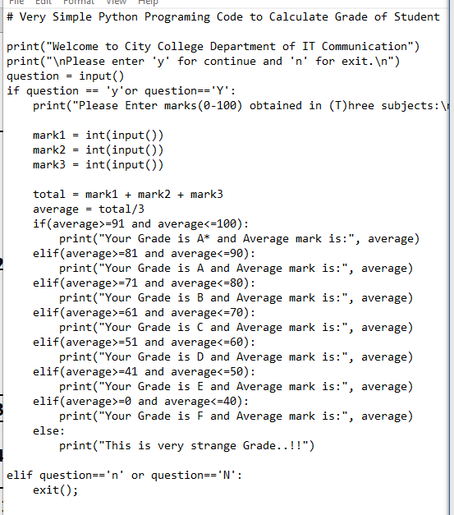

Task 3 - What kind of network?
Watch this video: https://www.youtube.com/watch?v=YF84Kebs7yU
Name each network topology and provide a brief description of each using either the articles provided, or your own research and consider their use, advantages and disadvantages
The following articles will help you in this task:
https://blog.finjan.com/a-closer-look-at-network-topology/
https://www.rcrwireless.com/20161017/big-data-analytics/network-topology-guide-tag31-tag99
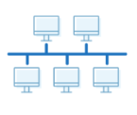

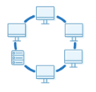

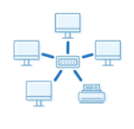

Task 4 - What are WAN & LAN?
Watch the following video explaining networks
https://www.youtube.com/watch?v=4_zSIXb7tLQ
- Give a short description of a WAN & LAN network highlighting differences
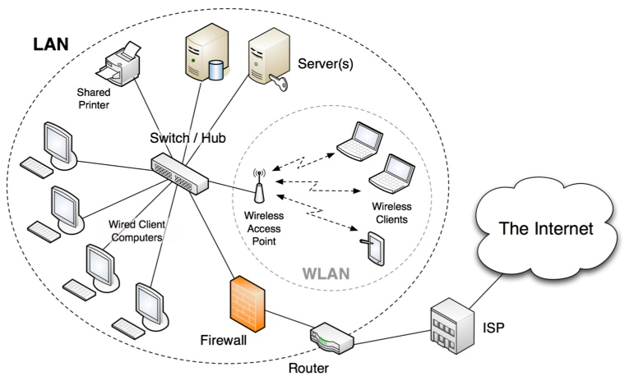
Use your own research to answer the following questions
- Which best describes the above network, WAN or LAN?
- What device has been used to connect this network with the Internet?
- What device could this be? (Central point)
- What would happen to the network if the wireless access point failed?
- What is the purpose of the firewall?
List the sources you have used to complete this task
The video describes several other types of network, but there are four main types. What are the other two? Provide a brief description of their use and compare with WAN & LAN
Task 5 - Understanding web files
A website is made up of different types of files. Have a read of the following article https://www.lifewire.com/types-of-web-files-3466474
Make a list of the most common file types and describe the components of each and what they are used for.
Task 6
Explain the following concepts and their purpose. Watch the video links below
https://searchsecurity.techtarget.com/definition/firewall
https://www.youtube.com/watch?v=iBI31dmqSX0
Concept | Description
Virtualisation
Firewall

- What is the difference between a virtual firewall and a software firewall?
- What are the benefits of virtualisation

We look forward to welcoming you to City College in September and exploring what you have found out through this project - which you should complete and bring with you to your first lesson.

