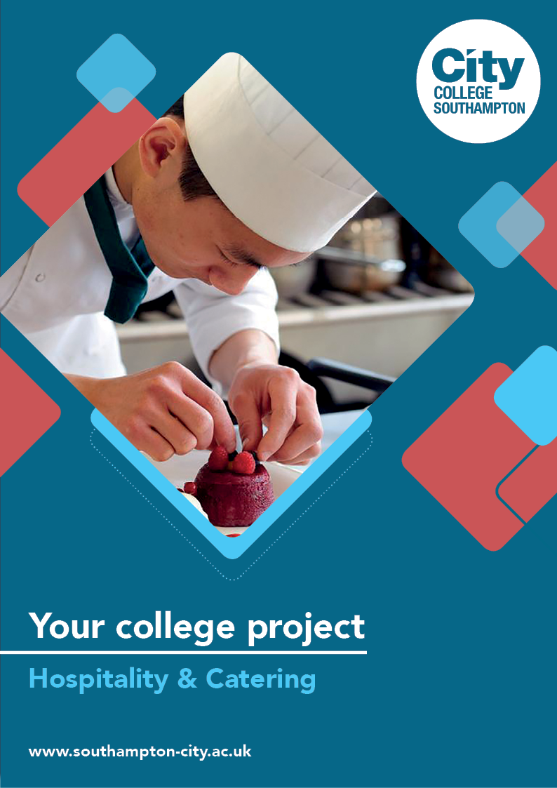
Hospitality & Catering Summer Project

Name: ______________________________________
Welcome to Hospitality & Catering at City College Southampton.
This is a series of short tasks to help you gain a little knowledge about Hospitality and Catering and the hospitality industry before you start with us. Please bring this with you on your first day of college.
Task 1
Imagine that you are planning a dinner party and you are inviting three guests. The guests can be members of your family or friends, or you can invite three famous people from the present day or the past.
- Decide on a suitable theme for your dinner.

- Describe the theme you have chosen, giving reasons for your choice.

- Design a three-course menu giving reasons for your choice of each dish.

- Prepare detailed recipes for each dish.

- Design a cocktail or mocktail to serve at your dinner and explain how it fits into your theme.

- Describe how you will decorate your table to reflect your theme.
To help you browse archives of recipes - look at www.greatbritishchefs.com, where you can get a vast quantity of recipes from chefs in the hospitality industry.
You might also find the following websites useful
Master Chef the Professionals
https://www.bbc.co.uk/programmes/b00mx9xb
The Great British Menu
https://www.bbc.co.uk/programmes/b0071y6r
Come Dine with Me
https://www.channel4.com/programmes/come-dine-with-me/episode-guide/
Stretch and challenge
Watch this episode of the latest series of the Great British Menu to see how professional chefs link books to dishes. In this episode each chef needs to cook a dessert to win a place at the Great British Menu final.
https://www.bbc.co.uk/iplayer/episode/m000j4bj/great-british-menu-series-15-finals-dessert
As you watch the video, answer the questions below:
- Tell us which your favourite dessert is and explain why it’s your favourite.
- Pick your least favourite dessert and describe the changes you would make to make to improve it.
- Choosing any four of the desserts, tell us if you agree or disagree with the judges’ comments. Explain your answer.
Task 2
We would like you to cook something of your choice. Maybe a Sunday lunch, your favourite dessert or a dish from the menu you created in Task 1. Take a number of pictures (from all angles - front, back, side and above). We will then share those pictures with each other during induction.

We look forward to welcoming you to City College in September and exploring what you have found out through this project - which you should complete and bring with you to your first lesson.

