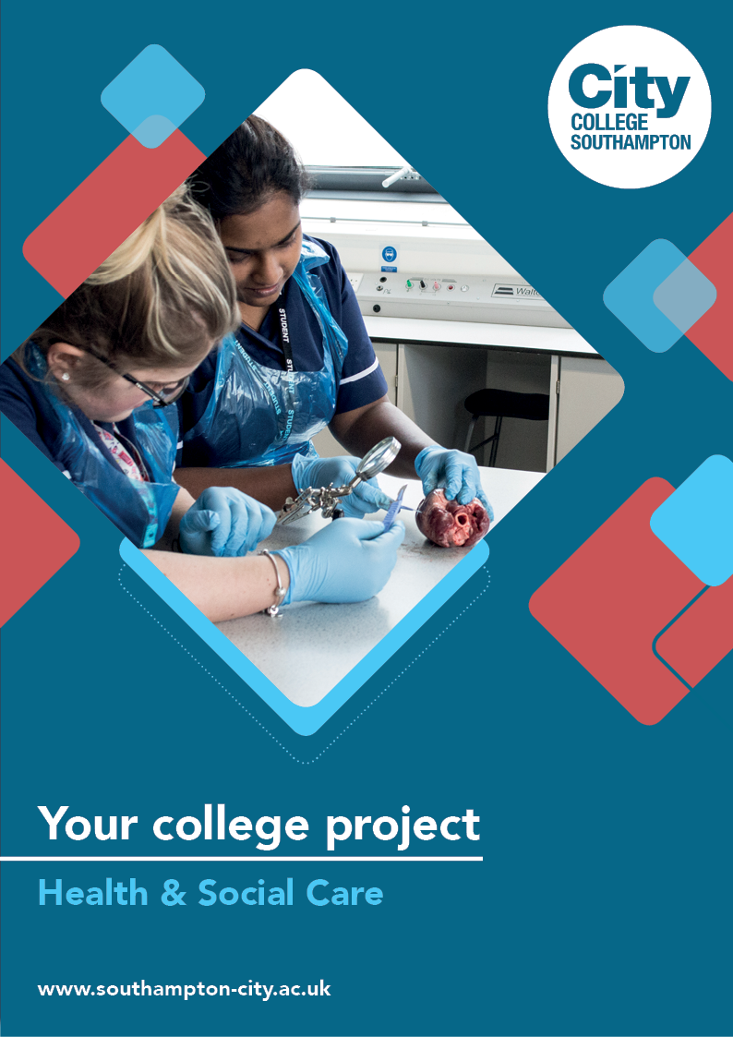
Health & Social Care Summer Project

Name: ______________________________________
Welcome to Health & Social Care at City College Southampton.
There are two tasks below for you to complete. You can either choose one task or complete them both if you have the time and would like to better prepare yourself for starting college. They are both designed to start you thinking about topics that feature regularly in Health and Social Care studies. Please bring this with you on your first day.

Task 1
Please create an interactive activity which could involve one of the following groups of service users (you can choose your own group).

Service users
- Elderly Dementia service users in a residential facility
- Primary school children aged 5 and 6 years
- Residents with physical disabilities who live within a supported residential community

Once you have chosen your group, research a health and social care setting (e.g. residential care home, day centre or school) and how it supports all service users. Your task is to create an activity suitable for the service users. Please research, collect and produce evidence of your activity. Your activity needs to include at least four features from the list below.
- 30 minute session period
- Music (20 songs)
- Movement (any movement is better than none)
- Making playdough and/or gloop from scratch
- Pictures (at least 12 and it can be on actors, musicians, singers or VIPs from four different decades)
- Colours (consider different ways you could incorporate colours into the activity)
- Numbers (think of the group’s different abilities)
Your activity should be fully inclusive (make sure you understand what this term means). Look at different ways your group can participate but remember that not all service users will choose to participate in every activity. What resources do you need to produce that will be used by them or yourself?
Helpful tips:
Remember to consider the health and safety of all involved. What steps could you take to make sure everyone can participate safely? Make sure your activity is enjoyable for all involved.
The evidence for your activity can be gathered in two ways:
- You could make a short video explaining your ideas and showing anything you have designed. Or take photos of the different ideas for your activity and what you have designed (if you use photos provide a description for each to explain what it is showing).
- You could provide a written reflection explaining what you would do, why you would do it and how well you think you have done. Also include images if that helps.
Task 2

This is a research task.

During these current unprecedented times of the Corona Virus we have all had to make significant changes to keep each other safe and life is very different in many ways. Some of these changes have been positive and some negative.

For this task you need to research one of the following life stages below. Think about how someone’s life has been changed who is from your chosen life stage. For example, someone in early childhood will not be able to access education in the usual way and this could have a negative impact on their reading and writing development. Someone in later adulthood might find themselves socially isolated and lonely.

The letters P.I.E.S each represent an aspect of life. Research what each stands for and use this to help you think about the different ways life is affected.

The following YouTube clips will help you with this:

https://www.youtube.com/watch?v=0zw-cI5rmZ0

https://www.youtube.com/watch?v=wIhJpk8U1R8

P __________
I ___________
E ___________
S ___________
The task will need to be completed in the form of a mini report (500-700 words) and can include any relevant pictures used to support your written evidence. Choose one of the following life stages for your report.

Life stages:

- Infancy
- Early Childhood
- Adolescence
- Early and Middle Adulthood
- Later Adulthood

Good luck!

We look forward to welcoming you to City College in September and exploring what you have found out through this project - which you should complete and bring with you to your first lesson.

