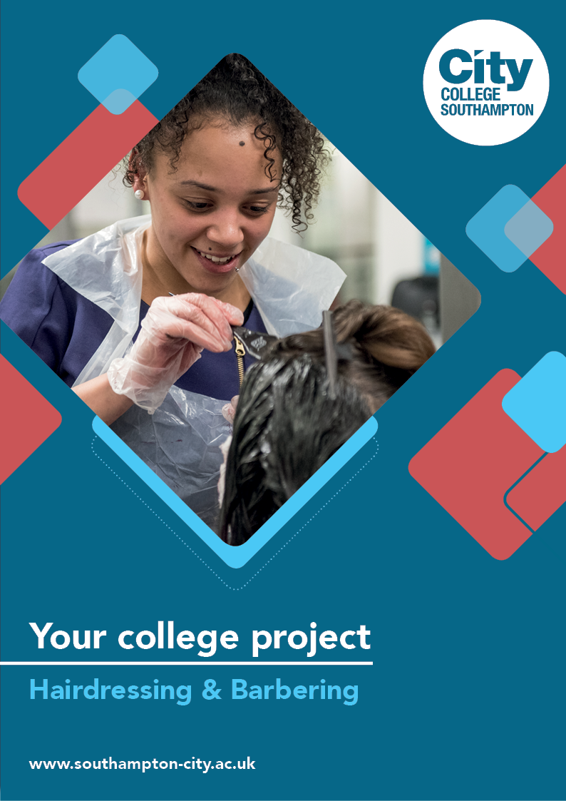
Hairdressing & Barbering Summer Project

Name: ______________________________________
Welcome to Hairdressing & Barbering at City College Southampton.
To prepare you for the beginning of your course in your chosen area (Hairdressing / Barbering) we have devised a Summer Project for you to complete. This will give you an insight into both the industry and the course which you will be undertaking in September. Please follow the brief and bring your completed project with you on your first day.
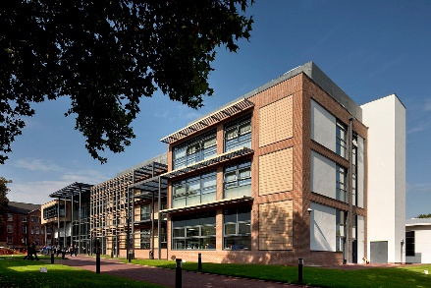
The hairdressing and barbering industry is ever changing, as a result of this, it’s important that hairdressers and barbers continually update their knowledge and practice. Below you will find some useful links to Industry professional practice:
Hairdressing
Hairdressers Journal - https://www.hji.co.uk/
NHFB - https://www.nhbf.co.uk/home/
Hairdressing council - https://www.haircouncil.org.uk/
Barbering
British Barbers Association - https://britishbarbers.com/
Barber Council - https://www.haircouncil.org.uk/pages/barberc.php
British Master Barbers - https://www.britishmasterbarbers.com/
Barbicide Covid-19 Certificate
In light of the recent events and to raise awareness to the precautions we will need to take within the industry please follow the below link:
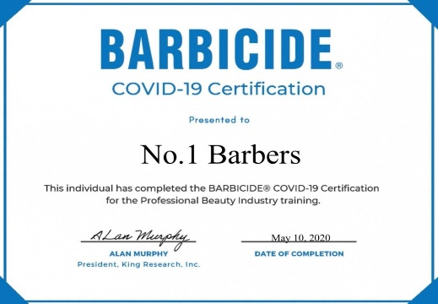
Completing this FREE course takes less than an hour earning you a portfolio-ready certificate showing your dedication to infection control in salons, spas, and barbershops.
Bring your certificate with you upon induction.
https://barbicide.com/certification/

Industry Study – use diagrams, pictures and links to show your research and support your answers:
- The hair structure is made up of three layers, name each layer and describe its function?

- Find a minimum of one person within your chosen industry (Hairdressing or Barbering) that inspires you. Tell us who they are, write a brief description of their career and why they inspire you.
Practical activity 1:
This shampooing and conditioning activity gives you tips and tests your knowledge of the correct techniques, in a range of situations and contexts.
It covers 2 learning outcomes:
- Maintain effective and safe methods of working when shampooing, conditioning and treating the hair and scalp.
- Shampoo, condition and treat the hair and scalp
Read both the shampoo and conditioning guide, watch the videos and then complete the online activity using the following link:
https://hairdressing.jisc.ac.uk/resources/shampooingandfconditioningactivity/
Practical activity 2:
Watch and Create: Please click on the following links and watch some of the hair up videos. Once you’ve watched the video clips, try to recreate;
Hairdressers - Hair up / plaited styles https://www.youtube.com/results?search_query=easy+plait+and+twist+hairstyles
Barbers – Blow dry pompadour styles https://www.youtube.com/results?search_query=easy+mens+blow+drys+
Take some photographic evidence of your work so you can track your progress at various points of the year to see how far you will have progressed.

As part of your study programme you will be required to carry out a minimum of 37 hours of work experience. In preparation for this please complete the following:
- Name a salon that you feel you would like to complete your work experience in. Research this salon. What services do they offer? What are their prices? Write a brief description as to why you would like to work there.

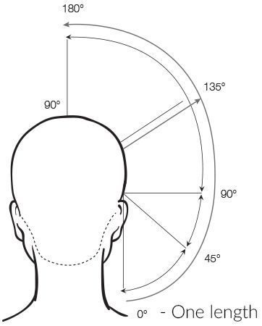
As part of your study programme, you will be continuing your study in Maths and English, both of these core subjects are used heavily within the industry, an example is shown below:
Example of maths: Angles are used when cutting hair

Activity: Make a list of other examples where maths and English is used within the hairdressing and barbering industry …

We look forward to welcoming you to City College in September and exploring what you have found out through this project - which you should complete and bring with you to your first lesson.

