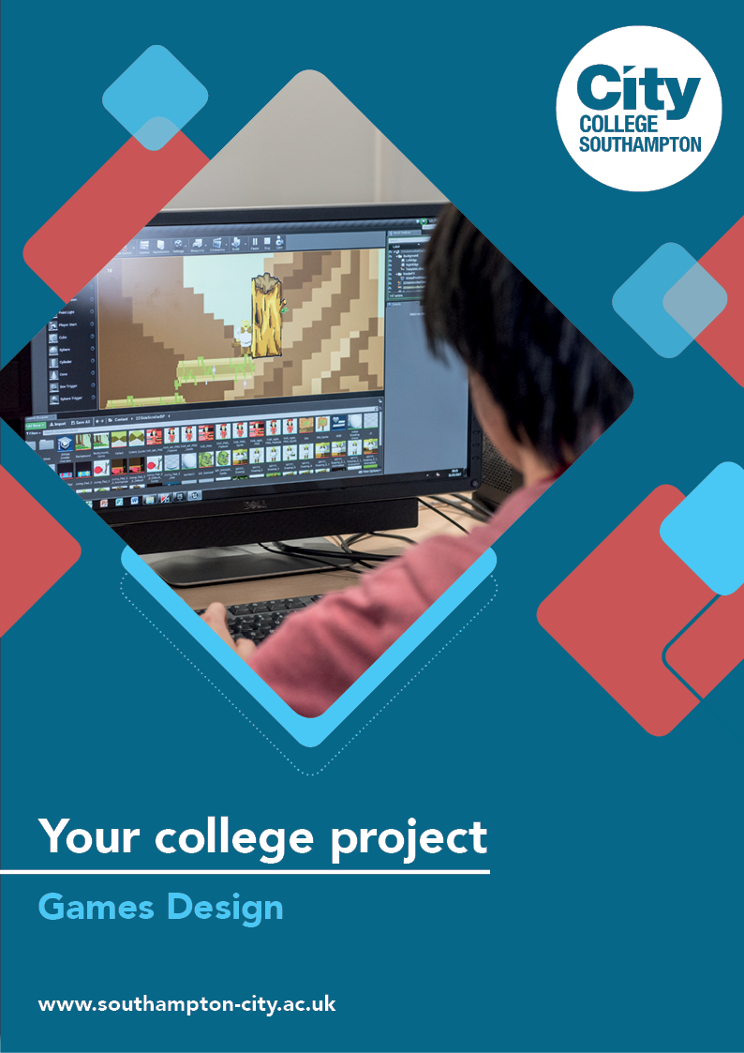
Games Design Summer Project

Name: ______________________________________
Welcome to Games Design at City College Southampton.
This summer project will help you gain a little knowledge about Games Design and the industry before you start with us. Please bring this with you on your first day.

Task: Character Designing
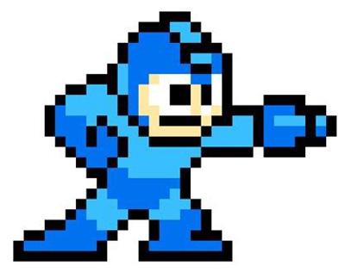
You are required to create an original 2D character sprite. It can be a new character for a game already out there, i.e. Hollow knight, Ori in the blind forest, Sonic games, Mario games or your own game idea. Please consider the art style and the target audience.

Use the templates provided or create your own by hand or computer whichever you prefer. This will be assessed when you start the course in September and will be used in your induction weeks at college. Being able to sketch is important but I am not expecting a masterpiece just communicate your idea as thoroughly as possible.

I have also added links/resources that could help you as you work through this but feel free to look for your own.

Looking forward to seeing your creations.

Debbie Avery, Video Games - Course Leader/Teacher

You must show evidence of the following using the template provided or your own:
- Create a mood board to demonstrate your inspiration for your character design.
- Show a front, side and back profile of your character.
- Name your character
- Backstory (where did they come from? e.g. where did Mario come from? Mario was born and grew up in the Mushroom Kingdom)
- Personality (what is the driving force behind your character's personal qualities?)
- Abilities, skills (what can your character do?)
- Alignment (Chaotic Good, Neutral Good, Lawful Good, Chaotic Neutral, True Neutral, Lawful Neutral, Chaotic Evil, Neutral Evil, Lawful Evil)
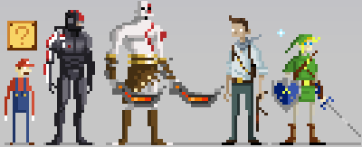
Here are some online resources to help you:

- How to tackle character design for 2D games
http://howtonotsuckatgamedesign.com/2014/08/tackle-character-design-2d-games/
- 27 top character design tips
https://www.creativebloq.com/character-design/tips-5132643
- Character Alignment https://tvtropes.org/pmwiki/pmwiki.php/Main/CharacterAlignment
- The nine alignments
https://www.anarchogeekreview.com/essay/the-nine-alignments

Character sheet

Student name
Character name
Mood board

Drawing (front) |  |  | Drawing (back)
Drawing (side)

Backstory
(where did they come from?)

Personality
Abilities, skills
Equipment
Alignment
(Chaotic Good, Neutral Good, Lawful Good, Chaotic Neutral, True Neutral, Lawful Neutral, Chaotic Evil, Neutral Evil, and Lawful Evil)

We look forward to welcoming you to City College in September and exploring what you have found out through this project including seeing your creations - which you should bring with you to your first lesson.

