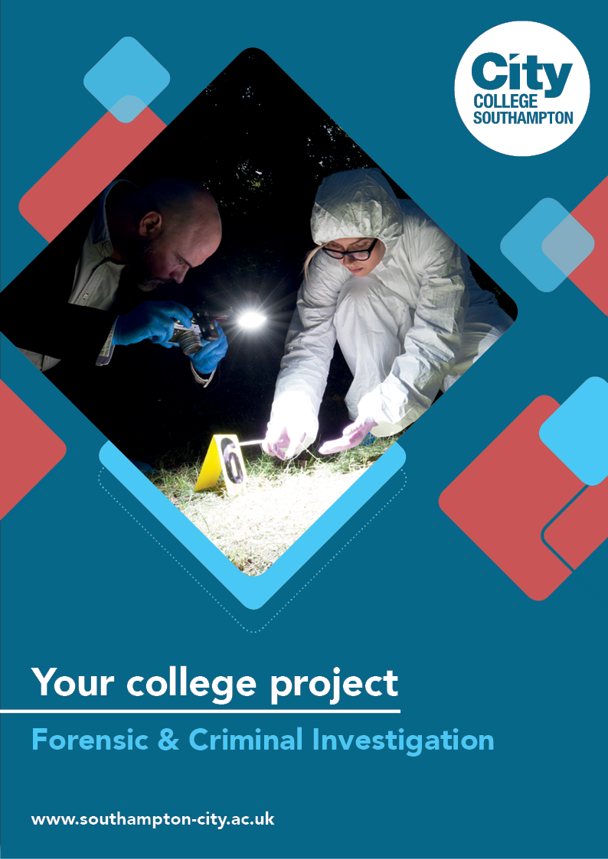
Forensic & Criminal Investigation Summer Project

Name: ______________________________________
Welcome to Criminal and Forensic Sciences at City College Southampton.

This summer project will help develop your knowledge of the Criminal and Forensic Sciences subject and its industry. Completing this task will give you an idea of part of your course. Please bring your completed project with you on your first day.

Task 1

‘Born to Kill’ - Are murders ‘predisposed’ (born) to kill or are they ‘created’ by environmental factors including our early childhood experiences?

Case studies:
- Aileen Wuornos
- Fred West
- Ted Bundy
- Jeffrey Dahmer

Task: Using the question above along with one of the case studies, your task is to write an essay of no more than 650 words which answers this question.

Before you start you will need to conduct some research by completing the questions and short activities shown below.

- What is the difference between nature and nurture in psychology?

- Conduct some research using books, YouTube videos or the internet on your chosen criminal and write a short biography of their life and crime. The YouTube clips below are examples of what is available to help you investigate your topic:
- https://www.youtube.com/watch?v=PUjzD9njgZc
- https://www.youtube.com/watch?v=_P7WVCcNOpE
- https://www.youtube.com/watch?v=bY0PqtRsX_A
- https://www.youtube.com/watch?v=48rhBfYUu48
- https://www.youtube.com/watch?v=Xe5OixqeLVw

- Create a list of factors that led to the crimes being committed and identify if you think that they are due to are either ‘nature’ or ‘nurture’ in the table below. You may need to add more rows.

Nature | Nurture

- ‘Born to kill’- Are murders ‘predisposed’ (born) to kill or are they created by environmental factors including our early childhood experiences?
Now answer this question using the evidence that you have gathered.

We look forward to welcoming you to City College in September and exploring what you have found out through this project - which you should complete and bring with you to your first lesson.

