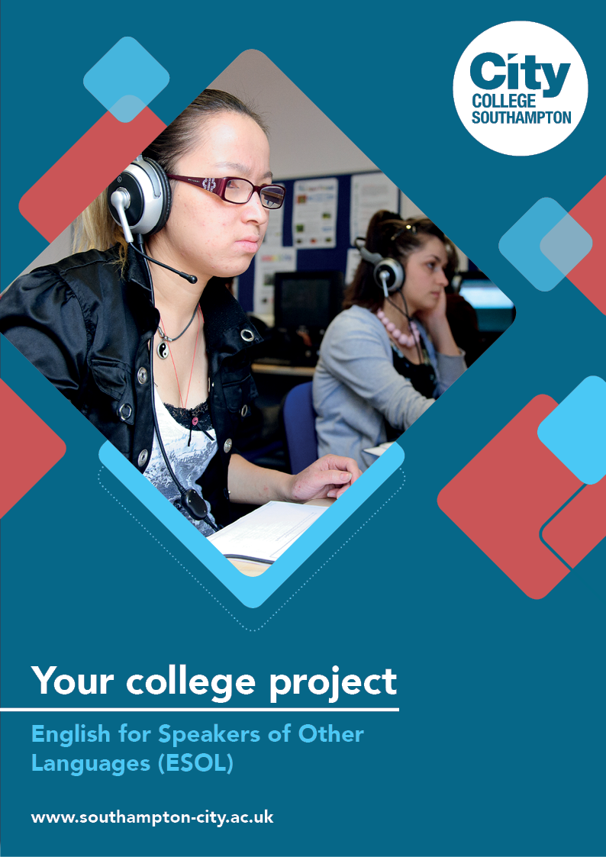
ESOL Summer Project

Name: ______________________________________
Welcome to ESOL at City College Southampton.
This is a series of short tasks to help you prepare for your ESOL course before you start with us. We would like you to complete the section you feel most comfortable with – Beginner, Intermediate or Advanced. You are welcome to complete more than one section if you like. Please bring this with you on your first day.

Activity Section 1 – For Beginners
A). My Goals
Answer the following questions.
1. What made you come to the UK and take this course?

2. What and where have you studied before?

3. What do you want to do in the future and why?

4. What do you hope to get out of your time at College? (GOALS)

B). Write a postcard to your family from abroad.
Postcard message:

C). Free Time
Write 7 sentences using the activities in the pictures above.
1.
2.
3.
4.
5.
6.
7.
D). Parts of speech
Look at the sentences you have written and pick two or three examples of the following parts of speech.
 | Example 1 | Example 2 | Example 3
Nouns
Pronouns
Adjectives
Verbs
Adverbs
Prepositions
Conjunctions
Interjections

You can watch this video to help you https://youtu.be/PZvqsyS-mRg
Activity Section 2 – Intermediate
A). My Goals
Answer the following questions.
1. Why did you decide to come to the UK?

2. Where did you study before? What did you study there?

3. What do you want to do in the future and why?

4. Are you worried about anything (perhaps accommodation or work)?

5. What do you hope to achieve here at the College? (GOALS)

6. What will you need to do to be successful? (ACTION POINTS)

B). Grammar
Visit this web page and complete these online exercises on sentence structures and conjunctions. https://www.grammar-monster.com/key_stage_tests/conjunctions_using_and_key_stage_1_sentence_level.htm
C). How are your phrasal verbs? Have a go on this website and complete the exercises:
https://esol.britishcouncil.org/content/learners/grammar-and-vocabulary/english-grammar/phrasal-verbs
D). Researching a building/monument in Southampton
Use the research sheet below to find out about a building or monument in Southampton and make notes. When you have finished, use your notes to write about your building/monument.
What is the name of the building/monument?

Where is the building/monument?

When was the building/monument built?

Who designed it?

What was the building/monument used for in the past?

What is the building/monument used for today?

What do you like about the building/monument?

Can you visit the building/monument? Do you have to pay?

Any other interesting facts

Activity Section 3 – Advanced
A). My Goals
Answer the following questions.
1. What made you come to the UK and take this course?

2. What can you tell me about your educational background? What have you studied before?

3. What do you want to do in the future and why?

4. Are you worried about anything (perhaps accommodation or work)?

5. What do you hope to get out of your time at College? (GOALS)

6. What will you need to do to be successful? (ACTION POINTS)

B). Grammar
Visit this web page and complete the tests. https://www.grammar-monster.com/tests/verb_tenses_test.htm. Make sure you know present simple, present progressive, past simple, past progressive and present perfect tenses well. There are links to practice these at the bottom.
C). Researching a building/monument in Southampton

Use the research sheet below to find out about a building or monument in Southampton and make notes. When you have finished, use your notes to write about your building/monument.

What is the name of the building/monument?

Where is the building/monument?

When was the building/monument built?

Who designed it?

What was the building/monument used for in the past?

What is the building/monument used for today?

What do you like about the building/monument?

Can you visit the building/monument? Do you have to pay?

Any other interesting facts

We look forward to welcoming you to City College in September and exploring what you have found out through this project - which you should bring with you to your first lesson.

