

**Engineering Summer Project**

Name: ______________________________________

Welcome to Engineering at City College Southampton. This is a series of short tasks to help you gain a little knowledge about the engineering industry before you start with us. Please bring this and any additional notes with you on your first day.

**Section 1: Health & Safety and Work Experience**

At City College the Engineering department needs to be a safe environment for all learners. The College is responsible for setting up safe ways of working and you are responsible for knowing them and carrying them out.

There are many hazards within the engineering industry. It is vital that you know and understand these dangers and take the necessary steps to avoid accidents.

In your first weeks at City College you will complete a safety induction to enable you to carry out workshop activities safely. Research into workshop safety before college starts in September will develop your knowledge and give you an insight to tasks you will be completing in your first week of your engineering course.

**Basic Personal Protective Equipment**

Your engineering course requires you to work in two of the workshops at City College, one of the workshops is the engineering workshop which consists of workbenches where you will learn to use various hand and power tools, drilling machines, metal lathes and milling machines. The other workshop is the fabrication and welding workshop which consists of workbenches where you will learn to use hand tools and power tools, guillotines, drilling machines and various welding equipment.

To work in these workshops you will be required to wear PPE (personal protective equipment). PPE equipment can include items such as eye protection, overalls, masks, gloves, safety footwear, hairnets and high-visibility clothing.

Looking at some of the equipment you will be using in the workshops, research what PPE you will be required to wear and answer the questions below.

**Overalls**



Why should you wear overalls and what type should they be so that they are suitable for both workshops?

[](http://images.google.co.uk/imgres?imgurl=http://www.toolstation.com/images/library/stock/webbig/55135.jpg&imgrefurl=http://www.toolstation.com/shop/Clearance/Workwear/d50/sd2679&usg=__YlTYg-aec5EYfL__32XCZOCXu8w=&h=500&w=500&sz=42&hl=en&start=42&um=1&tbnid=3rXeEM5Ul_dYBM:&tbnh=130&tbnw=130&prev=/images?q%3Dsafety%2Btrainers%26ndsp%3D20%26hl%3Den%26lr%3D%26safe%3Doff%26rlz%3D1W1GGLA_en-GB%26sa%3DN%26start%3D40%26um%3D1%26newwindow%3D1)**Safety Shoes**

Why should you wear safety shoes?

**Other**

[](http://images.google.co.uk/imgres?imgurl=http://richardwiseman.files.wordpress.com/2009/05/question-mark3a.jpg&imgrefurl=http://richardwiseman.wordpress.com/2009/05/21/its-the-friday-puzzle-9/&usg=__yhPHj8Jzef5r_G33QVt_NxaHiIU=&h=375&w=300&sz=9&hl=en&start=17&um=1&tbnid=RcKEWbm16NCR_M:&tbnh=122&tbnw=98&prev=/images?q%3Dquestion%2Bmark%26hl%3Den%26lr%3D%26safe%3Doff%26rlz%3D1W1GGLA_en-GB%26sa%3DX%26um%3D1%26newwindow%3D1)

What other Personal Protective Equipment do you think you may need to use at some point while welding or using different machines in noisy workshops?

**Safety Signs**

Working safely in an engineering environment requires employers to provide safety signs to raise awareness of risks to health and safety. There are different types of safety signs in general use. Each have a designated shape and colour and have to ensure that information is provided in a standard format with minimum use of words.

Below are five different types of safety signs, can you research and describe what type of sign each one is and what it is used for.

What type of sign is this and what is it used for?

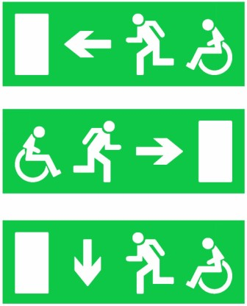



What type of sign is this and what is it used for?

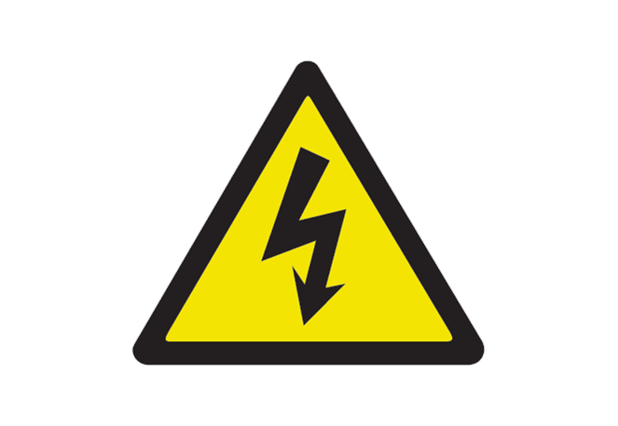

What type of sign is this and what is it used for?

What type of sign is this and what is it used for?

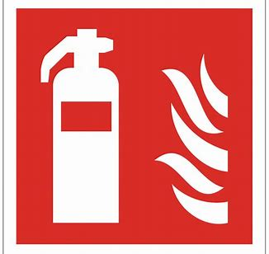



What type of sign is this and what is it used for?

**COSHH symbols**

In engineering you will work with all kinds of materials and substances some of which can cause harm. COSHH is the law that requires employers to control substances that are hazardous to health. These substances can be in the form of chemicals, fumes, dust, vapours, mists, gases and biological agents. Products that contain hazardous substances will be supplied with labels on that use COSHH warning symbols to indicate the level of danger.

What does COSHH stand for?

Shown below is the nine COSHH symbols.

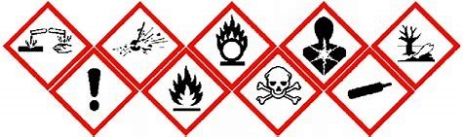

Can you find out what the nine COSHH symbols mean?



Have a look around your house and see if you can find some household cleaning products that have a COSHH label displayed on the label.

**Risk Assessments**

As part of your workshop safety induction you will learn how to carry out a risk assessment. This is an activity you will carry out throughout your course whenever you go to use any tools or machinery in the workshops.

When carrying out a risk assessment you have to consider any hazards and any risks.

A HAZARD is something that has the potential to cause harm.

The RISK is the chance that someone could be harmed by the hazard.

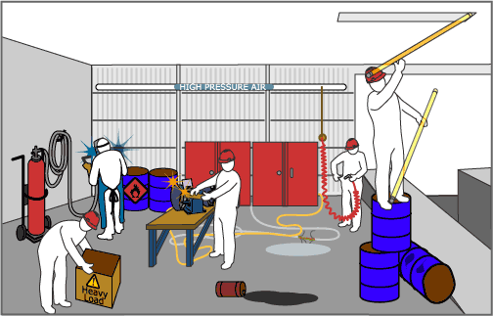

List the hazards you can find in the above picture and briefly describe what the risks of that hazard could be.

**Who is responsible for safety in the workshop?**

The Health and Safety at Work Act 1974 (HASAWA) is the legislation that industries all over the country follow to ensure safety in the workplace. Before you start your course in September read about the Health and Safety at Work Act 1974 and find out who will be responsible for safety in the workshop when you are working in there.

Below are some useful webpage links to help you find out required information for the above.

<https://www.hse.gov.uk/toolbox/ppe.htm> (PPE)

<https://www.hse.gov.uk/pUbns/priced/l64.pdf> (safety signs)

<https://www.hse.gov.uk/risk/controlling-risks.htm> (risk assessments)

<https://www.bbc.co.uk/bitesize/guides/zcs4ng8/revision/4> (health & safety at work act)

<https://www.hse.gov.uk/legislation/hswa.htm> (health & safety at work act)

**Section 2 - Work Experience Task**

As part of your course you will be required to complete work experience within the engineering industry. It will be your responsibility to find a company that will allow you to go into their workplace to complete your work experience.

The engineering industry is so diverse and by you doing some research into the companies that are in the engineering industry you will be able to learn about the different types of engineering routes available and it may help decide which route you would like to aim for. Completing a work experience placement in your chosen route is really valuable and will also give you a taste of what work will be like and again help you decide if you still would like to take that route or maybe change direction.

Before starting college in September we would like you to research the different types of engineering careers available and see what interests you the most. Check to see what qualifications you will be required to gain to get you on the right track for your chosen career. See what routes are available for you to gain the correct qualifications whether it be college and university, or college and an apprenticeship.

You will need to then research and see what companies are around the area local to you so that you can potentially find a company of interest for you to complete a work experience placement at.

Some of the different industries to consider when researching are – aerospace, railway, marine and automotive. In and around Southampton there are companies for each of those industries. When you have decided which industry interests you the most investigate what companies or organisations are within travelling distance that you would be interested in contacting to see if they would allow you to complete the required work experience with them.

When you start college in September you will need to produce the details of at least three different companies that you would like to contact for work experience, the details should include the company name, address, telephone number and email address. With these details the college will then guide you through contacting the companies you have details for to help you gain a work experience placement.

**Section 3 – What do you know about Engineering?**

1. Can you identify the different types of Engineering and a brief description of what they do?

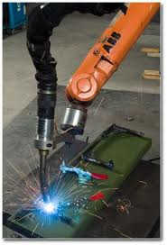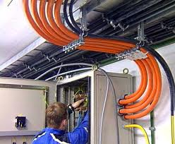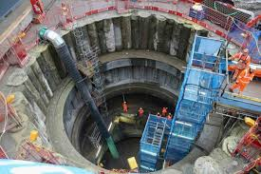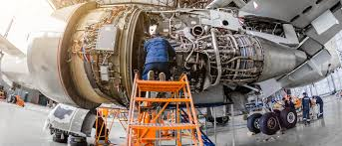

A.

B.

C.

D.

E.

F.

G.

H.

1. As a budding engineer, you are required to think in different ways.   
   Can you solve the following puzzle? (Think outside the box)

Joins up the dots by drawing only 4 straight lines and once started, the pencil may not   
leave the paper.

1. Link the comments in the box to one of the two fans?

Noisy

Easy to clean

Unsafe for children

More even cooling

Will collect dust easily

Easy to control

More expensive

[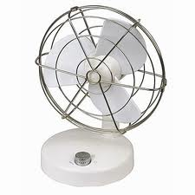](https://www.youtube.com/watch?v=BD4X22I)

1. What effort must be applied to the rope?
   1. 200 N
   2. 50 N
   3. 75 N
   4. 100 N
2. 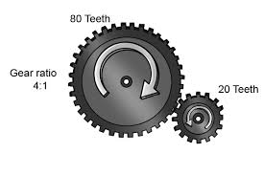This diagram shows a set of gears. If the gear with 80 teeth rotates at 100 RPM, what speed does the gear with 20 teeth rotate at?
   1. 200 RPM
   2. 100 RPM
   3. 400 RPM
   4. 800 RPM
3. 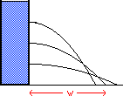A water tank has 3 holes drilled in the side, which of the diagrams will show how the water comes out.

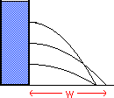

A B C D

1. 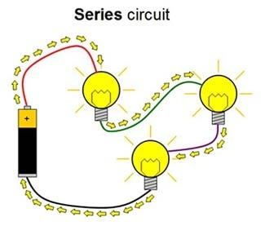The diagram shows a series circuit. The battery is 24 volts and the current flowing is 4 amps, what is the resistance of each of the lightbulbs?

(Formula V=I x R)

a) 6 Ω

b) 4 Ω

c) 2 Ω

d) 1 Ω

1. 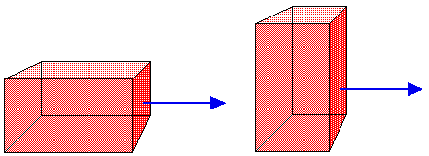You are trying to push a box. What will happen if you tilt the box on to another side?
   1. It is harder
   2. It is easier
   3. It will be the same
   4. It depends on the surfaces

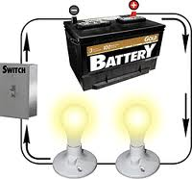

1. Which statement best describes the flow of electrons?
   1. Electrons don’t flow
   2. Electrons flow +ve to -ve
   3. Electrons flow -ve to +ve
   4. Electrons flow in both directions
2. Do you know what are the correct SI units for? (Example: Resistance is measured in Ohms Ω)  
   1. Force is measured in …………………………………………………
   2. Energy is measured in ……………………………………………….
   3. Power is measured in ……………………………………………….
   4. Mass is measured in …………………………………………….…..
   5. Torque is measured in …………………………………………..…
3. State whether the magnets shown will attract or repel one another?

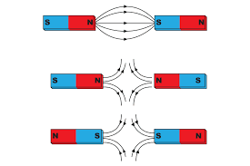

………………………………………………

………………………………………………

………………………………………………

1. Match the inventor to the invention (Note they are all British Engineers)

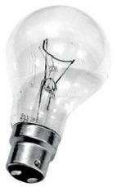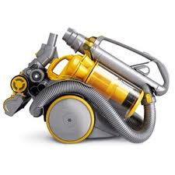Alexander Graham Bell, John Dunlop, Joseph Swan, James Dyson, John Logie Baird



……………………………….. ……………………………….. ……………………………….. ……………………………….. ………………………………..

**Section 4 – Advanced Engineering (have a go if you can)**

**Scenario**

You are a 2nd year apprentice working for a large engineering company, you are to work for 3 months in each department. You have been sent to the Clerk of works for the Berkeley pond nuclear decommissioning project. Before you start work, as part of the liaison co-ordinator team, between the design team at head office and the site project manager, the Clerk of works wants to test the knowledge you have gained from going to City College Southampton one day a week.

**Please read all of the questions first before starting this project.**

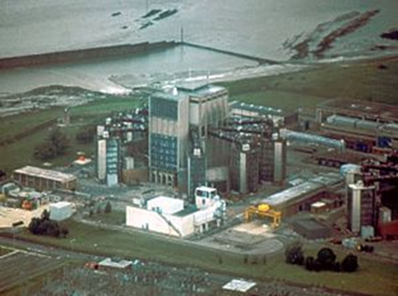

You are to write a brief answer to each of the questions covering Health and Safety, design, materials, electronics and fabrication.

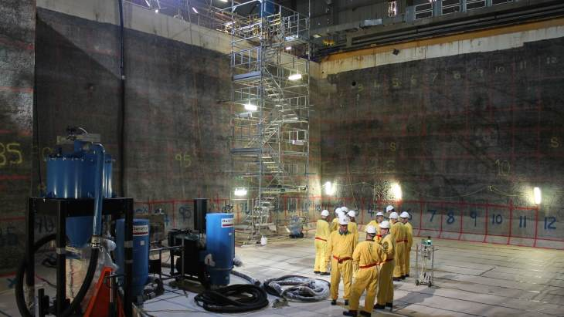

**Q1**

1. What is the main document covering Health and Safety in this country?
2. When working on site at the Berkeley nuclear power station, list 5 relevant Health and Safety regulations that you must comply with at all times?
3. Who is responsible for Health and Safety when working onsite?
4. Before any work is started a Risk Assessment must be carried out, this identifies the Hazard and the Risk, give a brief description of what they both are and an example of each.

**Q2**

Pebble Bed advanced high temperature reactor at UC Berkeley pond nuclear generating station.

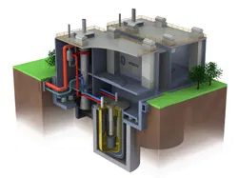

1. Above is a picture of the Pebble Bed advanced high temperature reactor, can you identify an electronic package for producing detailed drawings for the construction of this installation?
2. The picture above gives a representation of how the reactor will be made but from this drawing it can’t be made to the exact size and shape. List 4, 2D and 3D methods drawing?
3. The Clerk of works wants you to make a 3D model of a new valve seating design for the cooling system when he talks to the valve manufacturing company, which modelling package would you recommend to make this visual aid?

**Q3**

Different materials are used every day in industry, in some situations it is critical to get the right one or it can be very dangerous.

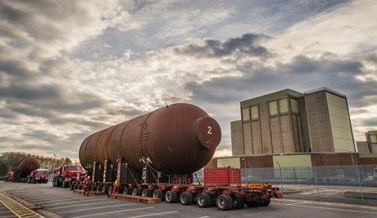

1. It is highly dangerous to have certain metals in contact with radioactive materials, what is the difference between Ferrous metals and Non-Ferrous metals.
2. Name 2 Ferrous metals and 4 Non-Ferrous metals.
3. Very few pure metals are used in industry, what do we call a mixture of two or more metals
4. Apart from metals List 3 different materials that would be used in a nuclear generating station.

**Q4**

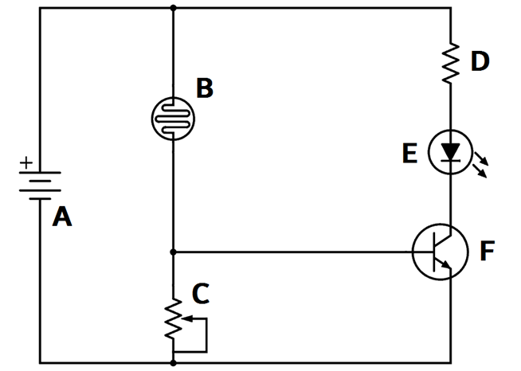

1. Above is an electronic circuit for a safety device operating a mechanical interlock, name all the components in the circuit A – F.
2. With the aid of sketches describe what it means if components are in series or parallel?
3. What is a circuit board made of and why?
4. Resistors are used in electronic circuits and the value of a resistor can be identified by a colour code system. Identify the value of the resistor below using the 4-band colour code method.
5. What is the reason for the 4th colour band on the above resistor?

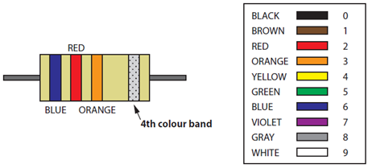

**Q5**

1. The air conditioning system is made from sheet metal that is cut to size, formed and joined by welding, bolting or riveting. List the three pattern development methods.
2. Below is a diagram showing three components of the air conditioning system in the decontamination chamber. Identify which of the three pattern development methods is used to develop each of the three components in the fabrication.

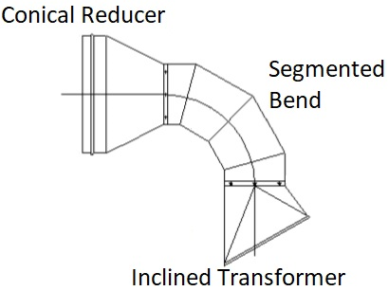

**We look forward to welcoming you to City College in September and exploring what you have found out through this project - which you should bring with you to your first lesson.**