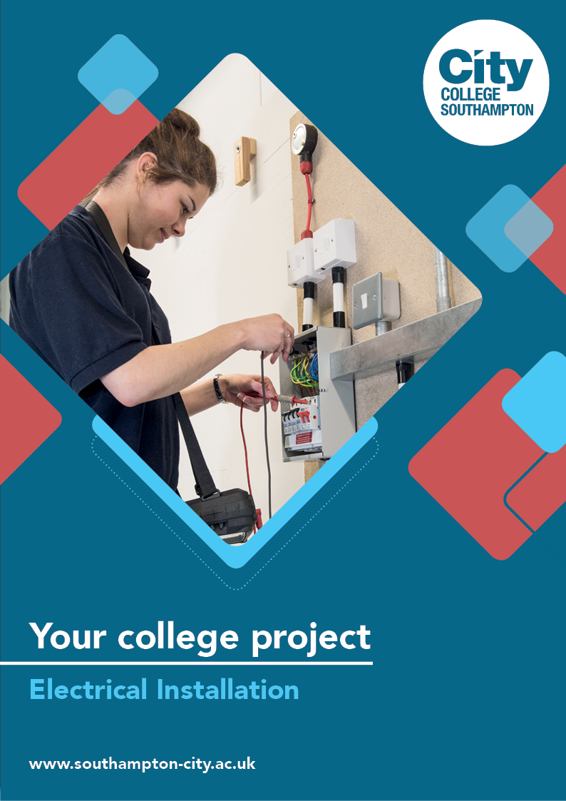
Electrical Installation Summer Project

Name: ______________________________________
Welcome to Electrical Installation at City College Southampton.
This is a series of short tasks to help you gain a little knowledge about electrical and the construction industry before you start with us. Please bring this with you on your first day.
Here at City College we have a long history of providing excellent education and training in the electrical trades. Indeed, I studied electrical installation here myself, quite a long time ago now, but the history of success here goes way back before my time as a student.

I am very proud to be passing on the knowledge and experience to you and your generation, as is all the electrical team.

Thank you for choosing City College Southampton.

Bob Henley B′Eng. (hons) PGCE Senior Teacher in Electrical Installation

Health and Safety plays an important role in your learning and working careers, because electricity and the environment that electricians work in are dangerous.

Here are a few Health and Safety activities to get you started.

Task 1 – Site Safety

The video below shows you what to expect when you visit a large site for the first time. It is called an induction and is designed to keep everyone on the site safe. Even very experienced workers have to complete the induction before they start work, as every site has different risks and hazards.

Watch the video and answer the following questions. Approximate times are given as a guide.

Site Safety Induction -
https://www.youtube.com/watch?v=eW7GBuaBuek

- Why does a building site need to be secure? (1:50)

- Can you identify four of the blue and white safety signs? What type of signs are blue and white and circular? (3:00)

- Give three examples of PPE (Personal Protective Equipment) used in construction and state what each is designed to protect you from. (3:45)

- Why do health and safety signs differ in colour? (6:20)

- Fire extinguishers are colour coded. Choose three extinguishers, name them, identify the colour coding and explain which types of fire each is used on. (6:40)

- Who are the HSE and what is their role in construction? (10:00)

- Who are the Health and Safety laws protecting in the Construction Industry? (11:20)

Task 2 - Fire Risks

- What are the three elements that make up the fire triangle?

- A fire has started in your place of work. If you see it first what must you do?

- What type of fire extinguisher should be used to put out an electrical fire?

- Identify what you think are the three most common causes of electrical fire in the workplace.

Task 3 – Hazard Spotting

Fill in the hazard sign boxes below.

Warning  sign | Type of  hazard | Effects of contact
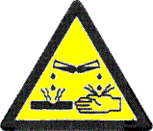
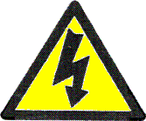
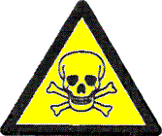

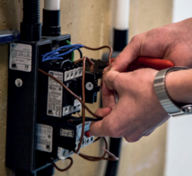
Working as an Electrician you will develop a large number of practical wiring and installation skills whilst you are at College which will help you to get a job as an electrician.

Complete this activity related to working in the industry.

Jobs in Electrical Installation and Associated Industries

Take a look at these stories from people working as electricians. Find out how they got into the industry, what they do and tips about working in their field.
Careers in Construction (Electrician) - https://www.youtube.com/watch?v=PoTas57SWyc

Use the internet to look up some of the many electrical job and make a few notes about what each job entails, typical salaries and qualifications required for the role.
Job Title | What the job entails | Qualifications required | Typical salary
Electrical Installer

Domestic Electrical Installer

Electrical Maintenance

Electrical Engineer

Electrical Tester

Electricians Mate

Electrical Wholesaler

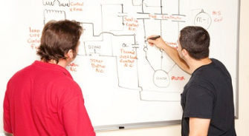
In the classroom - To be a good electrician you will need to have a good understanding electrical and mechanical science.

Answer the questions below to give yourself a kick start to your course.
The SI unit of resistance is the:
- ohm
- joule
- watt
- coulomb

2. The watt is a measure of:
a. potential difference
b. power
c. force
d. coulomb

3. A shower unit draws 20 A from a domestic 230 V supply. Calculate the
amount of power used.

a. 4.6 kW
b. 11.5 kW
c. 46 kW
d. 0.08 kW

4. Give a practical example of a class 1 lever.

5. What is Torque?

6. Match the wires to the colour in a domestic plug top.
1. Brown | a. Earth
2. Blue | b. Phase or Line
3. Green and Yellow | c. Neutral

We look forward to welcoming you to City College in September and exploring what you have found out through this project - which you should complete and bring with you to your first lesson.

