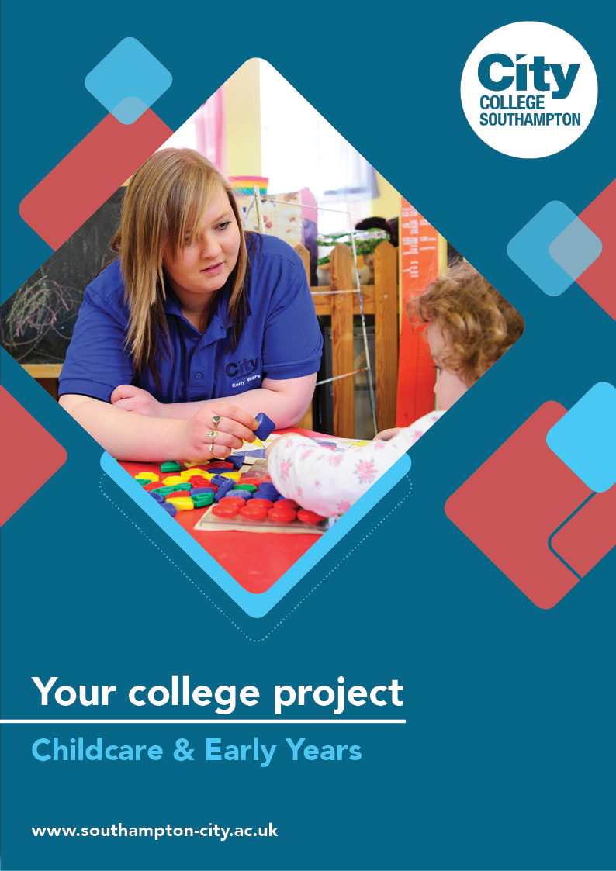
Childcare & Early Years Summer Project

Name: ______________________________________
Welcome to Childcare & Early Years at City College Southampton.
This is a series of short tasks to help you gain a little knowledge about Early Years before you start with us. Please bring this with you on your first day.

Activities, play and experiments are key in Early Years education to support the development of skills and confidence. The tasks you are being asked to do here will introduce you to some of the ways that early years’ educators can promote development through the use of engaging activities. In the first part you are being asked to view a short video which demonstrates how ‘simple to set up’ activities can be used to develop maths, phonics, reading and writing skills.
In task 2, 3 and 4 you will carry out your own science-based activity and evaluate how effective it could be in developing skills and curiosity. Task 5, if you have time, will get you to design and review your own activity.
Children are naturally drawn to science-based activities. They appeal to their innate curiosity and desire to make sense of the world. The best early years’ science activities are often ‘hands-on’ (and sometimes messy) and produce exciting, and sometimes unexpected, results. (Innate Curiosity is a key phrase in Early Years, if you are not sure what it is, this is a good time to do some research).
Below are a range of tasks, 1- 5 are science based and Task A (alternative task) is based on an outdoor learning area activity if you are unable to source the materials for the science themed activities as you will only need paper and pen or pencils, or a laptop/computer.

Task 1
Watch the following video and respond to the questions below.
https://www.youtube.com/watch?v=e5rek7q6mY0&t=20s
- Which activity did you like the most and why?
- What skills does the activity promote? Are there any other benefits to the child that the activity supports?
- Can you identify any potential hazards and how you might reduce these?
Task 2
Now choose one of the following activities to do in your own home and photograph/film the experience.
- Sink or float
This is a classic science activity that explores the principle of buoyancy (ability to float) and can be done with even very young children. Get a large container (e.g. a bowl or plastic box), fill it with water, and with the children collect a range of objects from around the nursery. The children then take it in turns to drop an object into the water – after guessing whether it will sink or float.
- Will it dissolve
This activity teaches children about solubility (ability to be dissolved), specifically whether a given substance will dissolve in water. You’ll need several small, transparent water containers (e.g. plastic or glass cups) and a range of substances to test (e.g. sugar, oil, salt, food colouring, rice, flour, vitamin tablets). Before dropping each substance into a cup ask the children to guess whether it will dissolve or not.
- Crazy cornflour slime
This activity is a little messy, but really fun and hands-on; children love exploring the strange properties of this cross between a liquid and a solid. For best results use a large shallow container that you can put on the floor, like a sand/water tray. Mix together cornflour and water until you have a slime consistency. Try punching the slime – it instantly turns solid. Roll some slime into a ball in your hand and then stop – it turns back into a liquid.
- Magic dancing milk
For this activity – an engaging introduction to chemical reactions – you’ll need a shallow dish, full-fat milk, food colouring, cotton buds and washing up liquid. Pour some milk into the dish, add some drops of food colouring, and then dab with a cotton bud dipped in washing up liquid. Use a few different colours at the same time for maximum impact, and try dabbing in different places.
Task 3
Write an account of your science activity. Think about the following questions
- What did you like about it?
- Did it turn out how you expected? Did anything surprise you?
- If you were to do it again, would you do anything differently?
Task 4
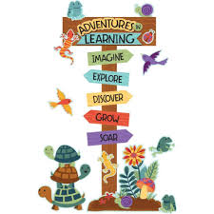
Research the benefits of children being creative and allowed to make their own predictions/choices and write a short statement on how the science experiment you carried out would support children to do this. The websites below will help you with this task.

Task 5 (If you have time)
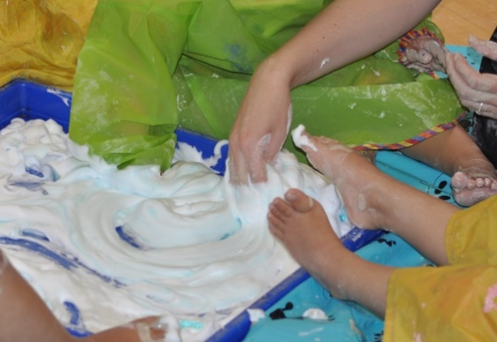
Can you design your own Science/Creative activity and write a plan that a practitioner could follow within a setting with a group of children. Think about how you could do it with children, the age of the children, what resources you would need, and how the activity would support their development. If you can, link this to development areas and the role you would play during the activity.
Below are a few links to website that will support you during this project.
https://www.foundationyears.org.uk/files/2012/03/Development-Matters-FINAL-PRINT-AMENDED.pdf
https://pstt.org.uk/resources/cpd-units/fostering-curiosity-in-early-years-science
https://www.thecreationstation.co.uk/inspiration/10-benefits-of-creative-activities-for-children-the-creation-station

Alternative task “Dream outdoor space”
Play and learning flow seamlessly between indoors and outdoors enabling children to make the most of the resources and materials available to them and develop their ideas without unnecessary interruption. Outdoor learning includes all that children do, see, hear or feel in their outdoor space. This includes the experiences that practitioners create and plan for plus the spontaneous activities that children create from their own ideas and experiences.
Task A - Outdoor area task
Look at the link below by Teach Early Years – they have given a good description on what an outdoor space in Early years can look like and what it should include.
https://www.teachearlyyears.com/enabling-environments/view/making-the-most-of-small-outdoor-areas
From this information, create your ‘Dream outdoor space.’ By using the headers from the link, create a poster, think about ‘zones’ you would create for different reasons, what resources to add and how to lay this out. Remember to make sure it is inviting for children to use, it helps them learn and promotes good mental health. You could draw this from a bird’s eye view in pencil or you could create 3D areas either hand drawn or on a computer.
- Stretch and challenge – create a mood board of the zones you would like in your outdoor space, collect pictures of the items to represent what your zones could look like.
- Write bullet points of how each zone would help children with below?
  - Physical (strength and balance)
  - Intellectual/cognitive (how they begin to understand)
  - Language/communication (speech, reading, writing)
  - Emotional (their feelings)
  - Social development (how they mix with others)
We look forward to welcoming you to City College in September and exploring what you have found out through this project - which you should complete and bring with you to your first lesson.

