Carpentry & Joinery Summer Project

Name: ______________________________________

Hi from Gary, Sean and John your carpentry lecturers at City College Southampton.

Your course, when you start, is split into 5 units which includes health and safety, principles of buildings, and how to prepare and use portable power tools etc.
So for your summer project we thought it would be fun to let you use your imagination and with the help of some research work through the 3 tasks below.
We would like you to include some health and safety guidelines when looking at constructing your house and what PPE (Personal Protective Equipment) you may need. For example there might be caution signs, stating heavy plant operating in this area or hard hats must be worn.

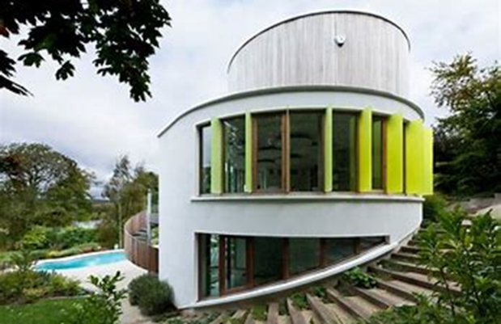

Have you ever dreamt of living in a house like this?
People like you and I have built houses like this, they have had an idea/vision, which they drew out on paper and then built it from their design.
In your chosen career everything you construct starts off as a drawing, this is known as a rod.

Your project is split into three tasks.
Task 1
Watch an episode of Grand Designs on Google/YouTube, this will give you some ideas/inspiration. Take note of lighting, heating, whether it is environmentally friendly etc.

Task 2
We would like you to design the house of your dreams, things to think about are:
Style - what it will look like?
Shape and position - will the sun enter the house all day long?
How will you power the lights, heating, etc?
Will it be environmentally friendly?

Task 3
Your final task is to design an item of furniture that will be in your house. Do some research on types of fixings, joints like mortise and tenons, dovetails etc.
Will it match the style of the house?
We will be looking to construct a scaled model of this item of furniture when you start the course if time permits.

Example of a basic rod for a chair
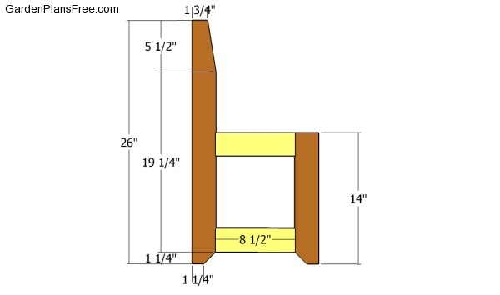

We look forward to welcoming you to City College in September and seeing your “Grand Design” - which you should bring with you to your first lesson.

