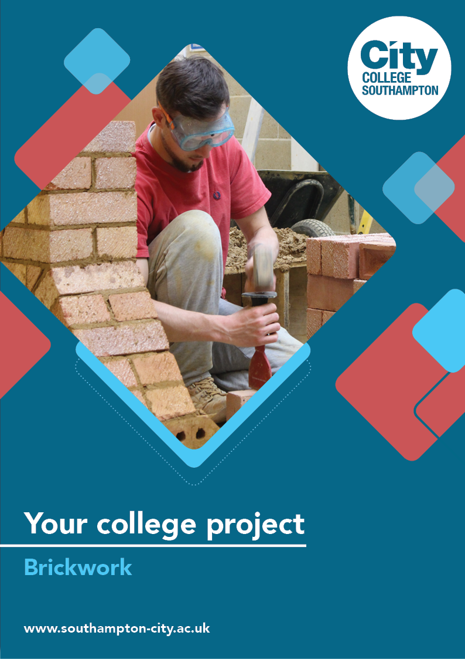
Brickwork Summer Project

Name: ______________________________________
Welcome to Brickwork at City College Southampton.
This is a series of short tasks to help you gain a little knowledge about bricklaying and the construction industry before you start with us. Please bring this with you on your first day.
Task 1
Health and safety in construction is particularly important because there are many potential hazards and good awareness of risks keeps everyone safe at work.
The video shows you what to expect when you visit a large site for the first time. It is called an induction and is designed to keep everyone on the site safe. Even very experienced workers have to complete the induction before they start work, as every site has different risks and hazards.
Watch the video and answer the questions. Approximate times are given as a guide.
Site Safety Induction - https://www.youtube.com/watch?v=eW7GBuaBuek
- Why does a building site need to be secure? (1:50)

- Can you identify four of the blue and white safety signs? What type of signs are blue and white and circular? (3:00)

- Give three examples of PPE (Personal Protective Equipment) used in construction and state what each is designed to protect you from. (3:45)

- Why do health and safety signs differ in colour? (6:20)

- Fire extinguishers are colour coded. Choose three extinguishers, name them, identify the colour coding and explain which types of fire each is used on. (6:40)

- Who are the HSE and what is their role in construction? (10:00)

- Who are the Health and Safety laws protecting in the Construction Industry? (11:20)
Now, have a look at the four images below. What safety hazards can you identify?
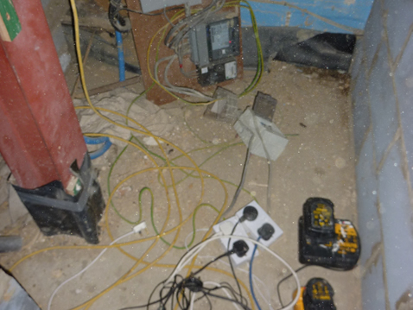 | 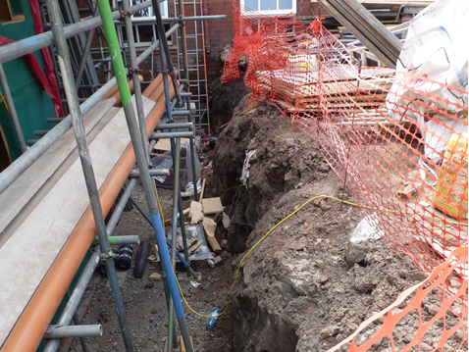
What hazards can you identify in this image? | What hazards can you identify in this image?
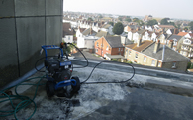 | 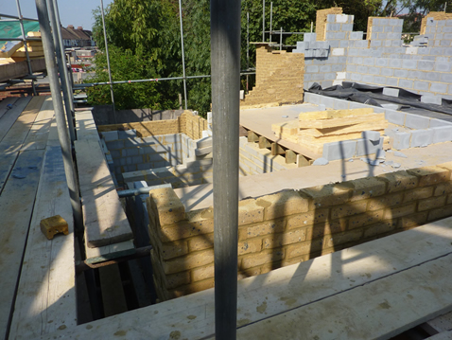
What hazards can you identify in this image? | What hazards can you identify in this image?

Look at the link to the Health and Safety Executive to check your answers.
https://www.hse.gov.uk/construction/campaigns/safersites/first-image-gallery.htm

Task 2
Mortar is the term used for a mixture of sand, cement and water that bricklayers use to lay bricks, blocks and stone. Watch this video, and answer the questions below. https://www.youtube.com/watch?v=Hl73ANpRa8I
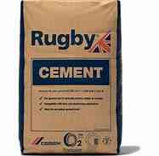
Which ingredient is left out of training mortar to stop it going off?
When mixing the cement, why do we add water to the cement board?
What is Admix and what is it used for?
What is the purpose of rolling the mortar?

Task 3
Within your first few weeks at College you will start building walls. Watch this video which shows you how to build a corner and answer the questions below https://www.youtube.com/watch?v=XT9J2DfxJe4
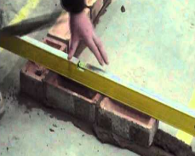
What is the square used for?
Why must you cut mortar with the trowel at a 45 degree angle?
The instructor uses a level at every course of the wall. What is a level used for?

Task 4
As a bricklayer you will need a set of tools. These are often split into hand tools and power tools. Most trainees build up a collection of hand tools over time and add the more expensive power tools at a later date. Make a list of the hand tools that you feel would make a good toolkit for you as a trainee bricklayer.
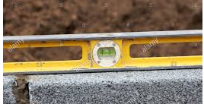
Now that you have a list of tools ready, use the internet to research the price of each tool.
Here are two websites that we recommend:
Screwfix - https://www.screwfix.com/
Toolstation - https://www.toolstation.com/
It is a good idea to compare prices from a number of suppliers as costs can vary.
Put the individual price per tool and the total cost into the table below. We will see who gets the best deal for their tools in induction.
Tool Name | Website address | Cost
Total for all tools

Take a look at these resources to find out more about working in construction.
- Latest Construction News - https://www.constructionnews.co.uk
- CITB supports the skills needs of the British construction sector - https://www.citb.co.uk
We look forward to welcoming you to City College in September and exploring what you have found out through this project - which you should complete and bring with you to your first lesson.

