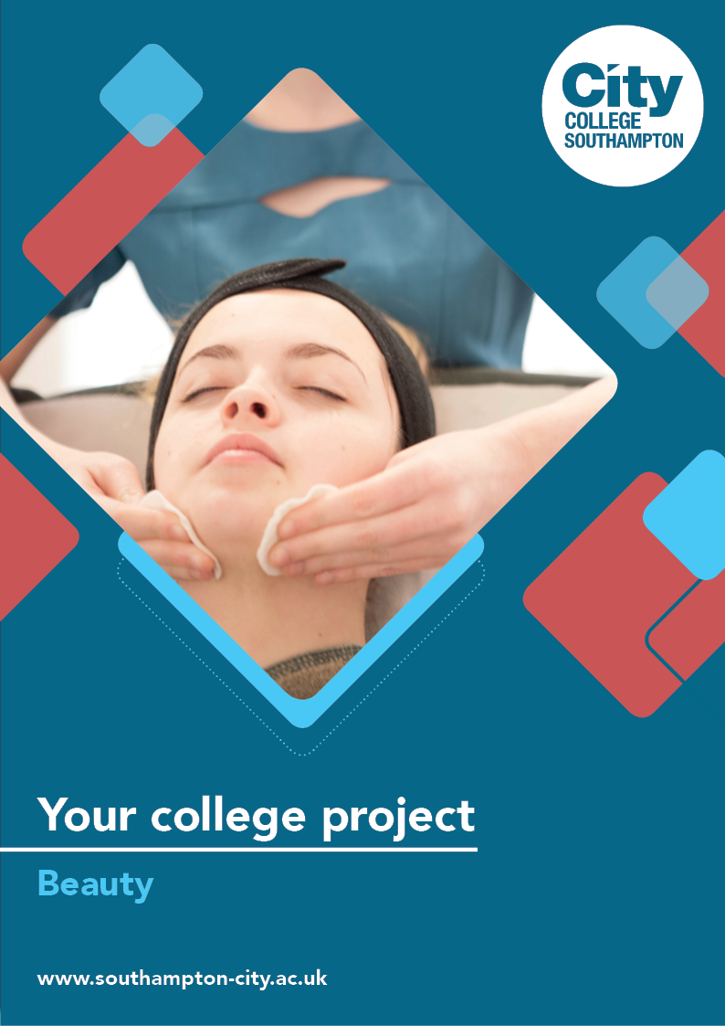
Beauty Summer Project

Name: ______________________________________
Welcome to Beauty at City College Southampton.
By studying a course in Beauty Therapy at City College you have ensured that you will learn all the required skills to become a successful therapist within the beauty industry.
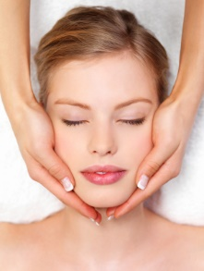
These skills will be fall into 3 main categories:
- Practical skills i.e. facials

- Underpinning knowledge i.e. anatomy and physiology of the human body

- Employer related skills i.e. communication, research, commitment, initiative, self-motivation and passion
With this in mind we have set you a ‘summer project’ to give you an insight into the beauty industry and the type of work we will be covering during your course. Please follow the brief and either bring your completed project into the college or be ready to email it to us on the first day that you arrive at the college.
Task 1
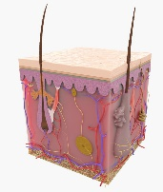
As beauty therapists we need to understand how the skin functions and why looking after our skin is so important.
The skin is made up of three main layers:
The Epidermis, The Dermis and The Subcutaneous.
Research the three layers detailing the structures that you would find in those layers and the overall functions of the skin.
Either draw or make a 3D model of the skin to help you learn.
Task 2
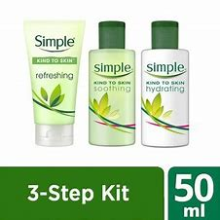
As beauty experts we must understand and convey the importance of a good skin care regime to our clients. To do this we need to first understand what skin type we have.

View the below link to help you learn the different skin types people can have and record your findings.

https://www.youtube.com/watch?v=mxRHAv7aelY

Now take the skin type test to determine your personal skin type and record your findings. https://www.youtube.com/watch?v=xkKH6_FsxAc
Using the skills you have learnt, we now need to consider the wider range of clients that we meet during our role as a therapist.
Task 3
Use your communication skills to complete a minimum of four case studies on your family/friends that you live with. Find out what skin type they have and what has led you to determine this. (Make sure they all take the skincare test you have just learnt so you can prove your findings!)
Task 4
Research on YouTube and prepare four ‘homemade masks’ to suit each of your case studies skin types (try to make 4 different masks for the 4 different skin types). Apply the mask to your volunteers. Take a picture for us to discuss and explain any differences you noticed in their skin after your application. Try one on yourself to practice!
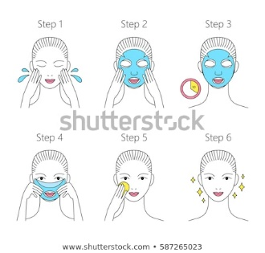
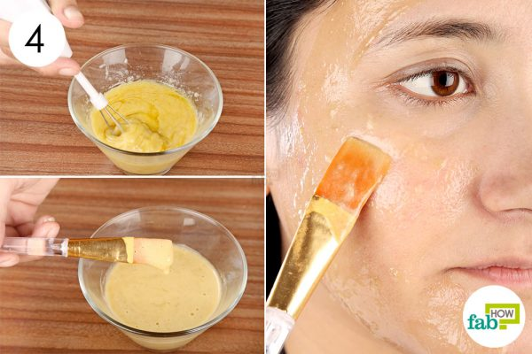
Here are some ideas to help!

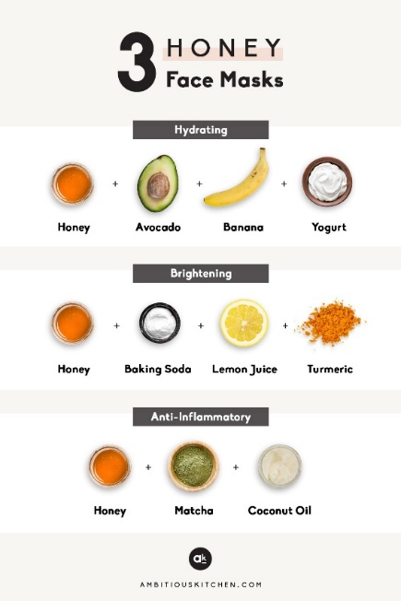

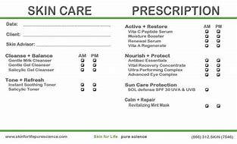

We look forward to welcoming you to City College in September and exploring what you have found out through this project - which you should complete and bring with you to your first lesson.

