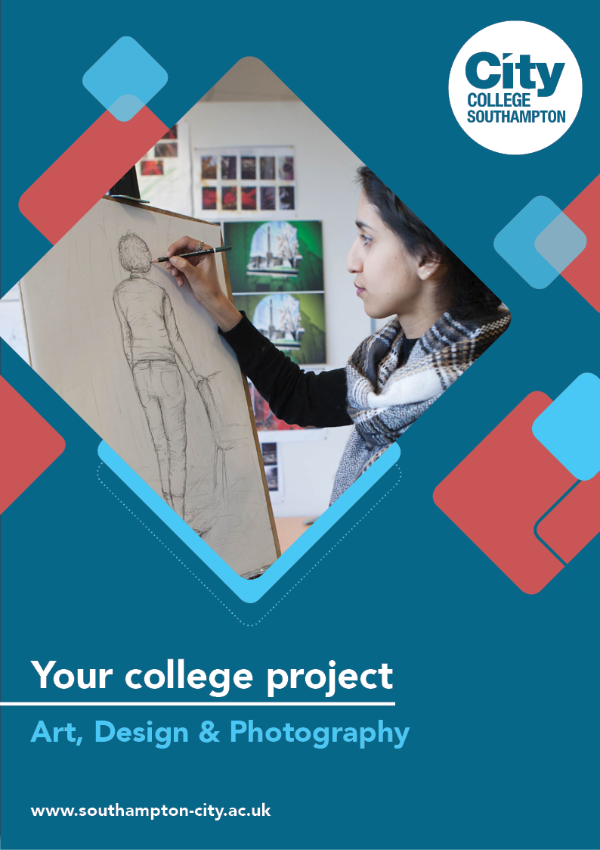

**Art, Design & Photography Summer Project**

Name: ______________________________________

Welcome to Art, Design & Photography at City College Southampton.

This is a series of short tasks to help you gain a little knowledge about Art & Design and Photography before you start with us. Please bring this with you on your first day.

UAL Level 3 Applied Diploma in Art & Design

UAL Level 3 Applied Diploma in Photography

UAL Level 2 Diploma in Art & Design

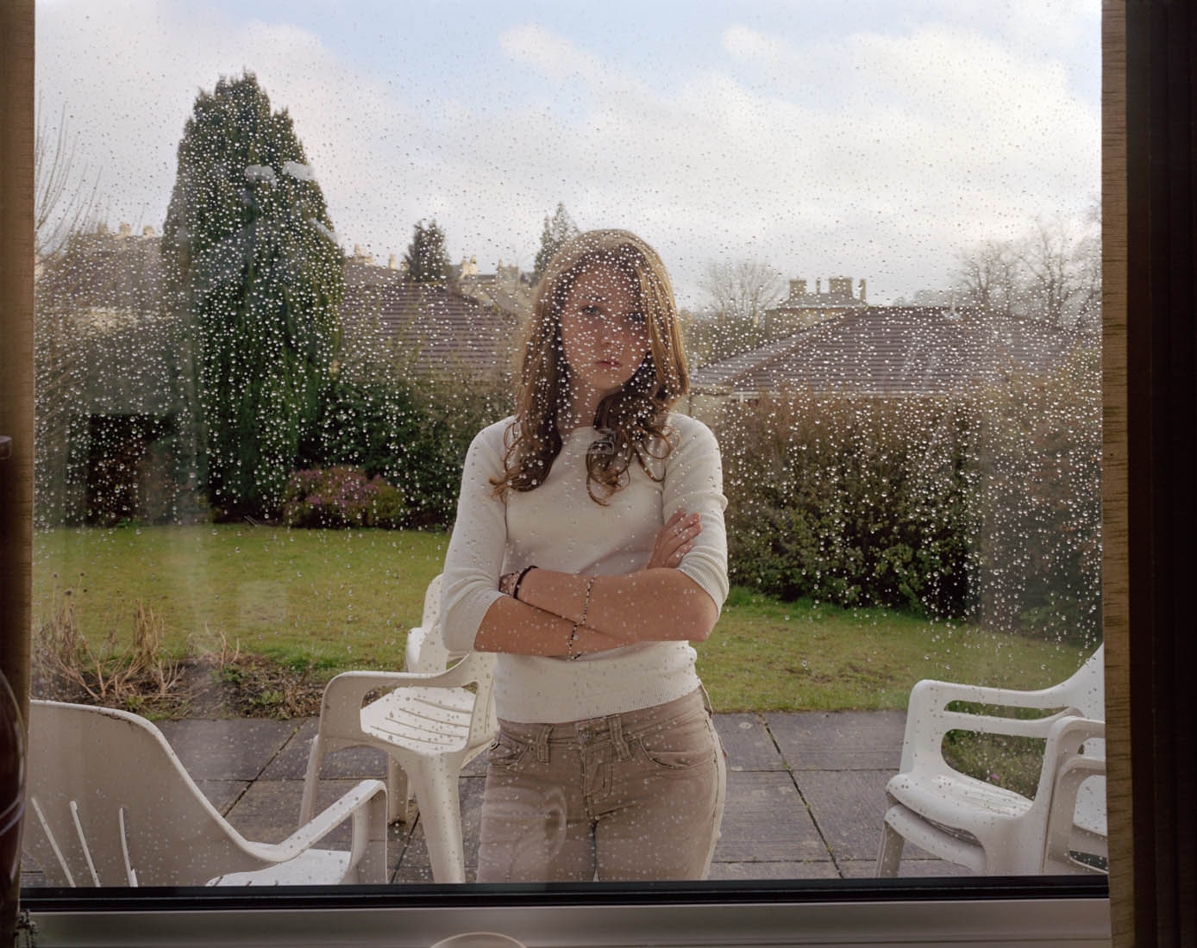

*Julia Fullerton Batten*

As part of studying art and design you are required to develop your use of visual language, to aid you in communicating your ideas and concepts.

**Task 1: Scavenger Hunt**

Choose any 5 of the following 10 challenges. Think creatively!

1. Find the smallest object in the room you are in. Draw it on the largest surface you can find, paying attention to detail.
2. Find something yellow, recreate it in blue.
3. Search for something shiny and put it in the light. Sketch it exaggerating the highlight.
4. Make an image with an unconventional material (e.g. paint with coffee granules or make a pattern out of stones)
5. Create a poster advertising a place you'd rather be (digital or hand-drawn). Include images and think about interesting typography.
6. Use close up on your phone to take ten images of texture in and around your home
7. If you have a pet take five photographs from your pets point of view
8. Pick three different colours and photograph five different objects in each colour (15 images)
9. (None Selfie) Take images of six different objects that will tell us something about you
10. Take photographs using five different sources of light

As part of studying art and design you are required to develop your use of visual language, to aid you in communicating your ideas and concepts.

**Getting started:**

Organise yourself with an A3 sketchbook - this task needs to be displayed in it. Think of fun interesting ways to display this work!

**Task 2:**

Below you will find a list of words that can be used to describe aspects of your creative processes. You are required to explain the meaning of the words and illustrate these further by providing visual examples of other artist works. You can source images from any discipline (painting, graphics, textile etc) for this purpose.

To develop this task add in some other words not on this list. Again find supporting images to help explain your meanings.

**Hint & Tips:**

* Where colour is important include a colour copy to help support meaning.
* Use a variety of sources not just the internet. Books, magazines, gallery visits.
* Reference the source e.g. the website URL, book title and author.

|  |  |
| --- | --- |
| **Word** | **Meaning** |
| Composition |  |
| Line |  |
| Form |  |
| Texture |  |
| Space (negative) |  |
| Colour |  |
| Juxtaposition |  |
| Perspective |  |
| Balance |  |
| Monotone |  |
| Chromatic |  |
| Negative |  |
| Positive |  |
| Harmony |  |
| Disharmony |  |
| Pattern |  |
| Practice |  |
| Theory |  |
| Scale |  |
| Shape |  |
| Dark |  |
| Light |  |
| Tone |  |
| Hue |  |

Please complete all of the tasks in your A3 sketchbook. Consider how you layout your pages, give them titles and think creatively!

If you have any questions about this project please email:

[victoria.rick@southampton-city.ac.uk](mailto:victoria.rick@southampton-city.ac.uk)

[phill.pepper@southampton-city.ac.uk](mailto:phill.pepper@southampton-city.ac.uk)

[sudhir.sood@southampton-city.ac.uk](mailto:sudhir.sood@southampton-city.ac.uk)

Useful *links to help get you started:*

<https://www.museofridakahlo.org.mx/en/the-blue-house/multimedia/>

Participate in lots of fun creative workshops with Pascal Anson:

<https://www.youtube.com/channel/UCtjb-kEKephsp_2bSo7bixg>

Catch up with Grayson Perry's Art Club:

<https://www.channel4.com/programmes/graysons-art-club>

Socially distant life drawing!

<https://www.bbc.co.uk/programmes/m000j45r>

<https://www.anothermag.com/art-photography/11779/nick-knight-roses-interview-albion-barn-exhibition-alexander-fury>

<https://www.cnet.com/how-to/5-fun-easy-photo-projects-you-can-do-at-home-with-just-your-phone/>

**We look forward to welcoming you to City College in September and exploring what you have found out through this project - which you should complete and bring with you to your first lesson.**